**Name: ……………………………………………………………Adm. No. ………………**

**Stream: ………………………………………. Student’s Sign. ……....**

**Date: …………………………**

**233**

**CHEMISTRY**

**END TERM TWO 2024**

**TIME: 2 HOURS**

**Kenya Certificate of Secondary Education (K.C.S.E)**

**FORM 3 END TERM TWO EXAM**

**INSTRUCTIONS TO THE CANDIDATES:-**

* Answer ***all*** the questions in the spaces provided.
* Write **your name** and **admission number, date** in the spaces provided.
* Mathematical tables and electronic calculators may be used for calculation.
* All workings **must** be clearly shown where necessary

**For examiner’s use only:**

|  |  |  |
| --- | --- | --- |
| **Question** | **Maximum score** | **Candidate’s score** |
| 1-4 | 60 |  |

*This paper consists of 6 printed pages. Candidates should check to ascertain that all pages are printed as indicated and that questions are missing.*

1. Air was passed through several reagents as shown in the flow chart below.

Gas **P**

Electrostatic

Precipitation

Concentrated Sodium Hydroxide

Air

Excess heated Magnesium Powder

Excess heated Copper turnings

Compressor

Fractionating column

C (-1830C)

Argon (-1860C)

Nitrogen (-1960C)

1. Name the major components of air. (2mks)

……………………………………………………………………………………………………………………………………………………………………………………………….......................

1. Write an equation for the reaction which takes place in the chamber with:
2. Concentrated sodium hydroxide. (1mk)

………………………………………………………………………………………………………………………………………………………………………………

1. Excess heated copper turnings. (1mk)

………………………………………………………………………………………………………………………………………………………………………………………………

1. Excess heated magnesium powder. (1mk)

………………………………………………………………………………………………………………………………………………………………………………

1. Name **one** gas which escapes from the chamber containing magnesium powder. Give a reason for your answer. (2mks)

…………………………………………………………………………………………………………………………………………………………………………………………

1. Name the substance that was eliminated by electrostatic precipitation. (1mk)

……………………………………………………………………………………………...

1. Name a reagent that can be used in place of concentrated sodium hydroxide. (1mk)

………………………………………………………………………………………………

1. Name substance **C.** (1mk)

……………………………………………………………………………………………

1. State **two** uses of gas **C.** (1mk)

………………………………………………………………………………………….............

1. Study the flow diagram **below** and answer the questions that follow.

Ethyne

**R**

**T**

**S**

**V**

**U**

W + H2SO4

C2H5Cl + HCl

Acidified KMnO4

Step III

Hydrogen chloride gas

Step II

Conc. Sulphuric (VI) acid

Step V

Step VII

Step V I

Reagent

X

Water warm

1 mole of hydrogen

Step I

(a) Name substances. (6 marks)

**R**…………………………………………………………………………………………….

**S** …………………………………………………………………………………………….

**T** ……………………………………………………………………………………………

**U** ……………………………………………………………………………………………

**V** …………………………………………………………………………………………..

**W** ………………………………………………………………………………………….

(b) Name reagent **X** and the condition required for the reaction in Step **VII** to occur. (2 marks)

………………………………………………………………………………………………………

………………………………………………………………………………………………………

(c) Name the type of reaction that occurred in

(i) Step **I**………………………………………………………………………….(1mrk)

(ii) Step **VII** ……………………………………………………………………… (1mark)

(d) Name the reaction that occurred in

(i) Step **II** ……………………………………………………... (1 mark)

(ii) Step **IV** …………………………… ………………………. (1 mark)

(e) Draw and name **two** structural isomers of C4 H10. (4 marks)

1. Use the grid below to answer the questions that follow. The letters do not represent the actual symbols of elements.

|  |  |  |  |  |  |  |  |  |
| --- | --- | --- | --- | --- | --- | --- | --- | --- |
|  |  | | | | | | |  |
|  |  |  |  |  | G |  | J |  |
| A | D |  | E | F |  | H | K | L |
| B |  |  |  |  |  |  |  |  |
| C |  |  |  |  |  |  |  |  |

1. Give the family name of the group in which elements B and C are members. (1mark)

………………………………………………………………………………………………………………………………………………………………………………………………………………………………

1. State and explain the different in reactivity between
   1. B and C (1mark)

………………………………………………………………………………………………………………………………………………………………………………………………………………………………………………………………………………………………………

J and K (1mark)

………………………………………………………………………………………………………………………………………………………………………………………………………………………………………………………………………………………………………………………………………………

1. How does the atomic radius of E compare with that of F? Explain. (2marks)

………………………………………………………………………………………………………………………………………………………………………………………………………………………………………………………………………………………………………………………………………………

1. Element R forms an oxide of the formula RO2 and belongs to period two. Indicate in the grid the position of R. (1mark)
2. Explain the trend in the melting points in the group of elements to which A and D belong. (1mark)

………………………………………………………………………………………………………………………………………………………………………………………………………………………………………………………………………………………………………………………………………………

1. Give the formula of the compound formed between E and K. (1mark)

……………………………………………………………………………………………………………………………………………………………………………………………………

1. Name the type of bond formed when A reacts with I. Explain. (2marks)

……………………………………………………………………………………………………………………………………………………………………………………………………

1. Give one use of element L. (1mark)

………………………………………………………………………………………………………………………………………………………………………………………………………………………………

1. Give the electron arrangement of an ion of

C …………………………………………………………………………….. (1 mark)

G …………………………………………………………………………… (1 mark)

4. a)The set-up below was used by a form three student to prepare a dry sample of gas **M**. Study

it and use it to answer the questions that follow:-

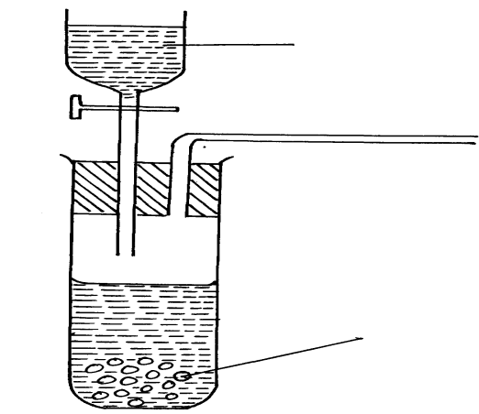

Zn(s)

Conc. HCl

(i) Complete the diagram to show how a dry sample of gas **M** can be collected (3mks)

(ii) State the identity of gas **M** (1mk)

………………………………………………………………………………………………………

iii) State two industrial uses of gas M. (2mks)

………………………………………………………………………………………………………………………………………………………………………………………………………………

b) What property of concentrated sulphuric acid is being employed in the above preparation?

(1mk)

………………………………………………………………………………………………………………………………………………………………………………………………………………

The set-up below was used to investigate the properties of hydrogen

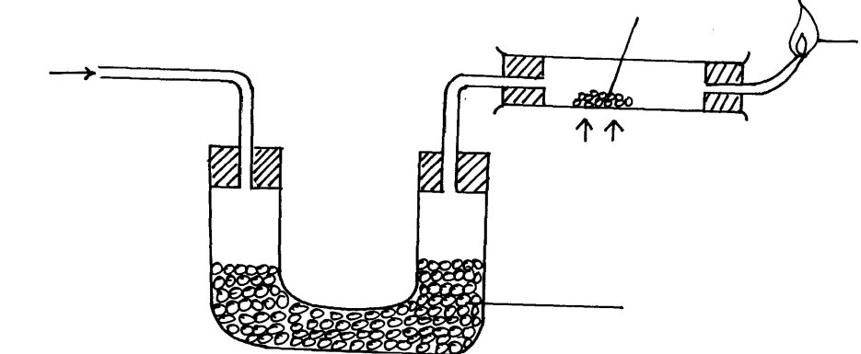

Dry hydrogen

Heat

Anhydrous Calcium Chloride

Blue flame

Lead (II) oxide

(i) State the observations that was made in the combustion tube as the reaction progressed to completion (2mks)

……………………………………………………………………………………………………………………………………………………………………………………………………………………………………………………………………………………………………………………… (ii) Write equations for the reactions ;

I) In the combustion tube (1mk)

……………………………………………………………………………………………

II) At the jet of the delivery tube (1mk)

………………………………………………………………………………………………

Naturally occurring boron exists as two isotopes, boron-10 B with a relative abundance of 20% and boron-11 B with a relative abundance of 80%.

(a) How many electrons does each atom of boron contain? (1mk)

………………………………………………………………………………………………

(b) How many neutrons does each atom of the most abundant isotope contain? (1mk)

………………………………………………………………………………………………

(c) Calculate the relative atomic mass of boron. (2mks)

(d) Make a diagrammatic representation of an atom of the least abundant isotope of boron

showing the distribution of electrons and composition of the nucleus. (2mks)

5.Classify the process below as chemical or physical changes (4mks

|  |  |
| --- | --- |
| **Process** | **Physical or chemical change** |
| (a) Fractional distillation |  |
| (b) Souring of milk |  |
| (c) Sublimation |  |
| (d) Neutralization |  |