* + - 1. **[Ecology (55 Lessons)](http://www.elimu.net/Secondary/Kenya/KCSE_Student/Biology/Form3/Ecology/Ecology.htm)**

1. a) What is synecology? (1 mark)

b) Name **two** abiotic factors in water that affect living organisms. (2 marks)

1. Complete the table below: (3 marks)

|  |  |  |  |  |  |  |  |  |  |  |
| --- | --- | --- | --- | --- | --- | --- | --- | --- | --- | --- |
| |  |  | | --- | --- | | **Disease** | **Causative agent.** | | Amoebic dysentry |  | |  | Schistosoma Mansoni | | Syphilis |  | | |  |
| 1. The diagram below represents recycling of nutrients in a certain ecosystem. Study it and answer the questions that follow.     Sunlight    Produce  Secondary  consumer      Dead  Mi  neral salts and humus    M  I  II    II     1. Name the tropic level represented by M. (1mark) 2. Name the process represented by I, II, and III. (3 marks) 3. Name the organism involved in process II. (1mark) 4. What would happen within the ecosystem if all secondary consumers were eliminated? (3 marks) 5. What is nitrogen fixation? (1mk)      1. Describe the nitrogen cycle. (20mks) | |  |
|  | |  |
| 6. The table below shows approximate numbers of organisms found in an ecosystem.   |  |  | | --- | --- | | **Type of organism** | **Numbers** | | Grasshoppers | Many | | Hawks | 3 – 4 | | Snakes | 15 – 30 | | Green plants | Very many | | Lizards | 80 – 120 |   a) Using the information in the table draw a pyramid of numbers. (3 marks)  b) Explain what would happen to the other organisms if all the lizards suddenly died off. (2 marks)  7. (a) Name the bacteria found in the root nodules of leguminous plant. (1 mark)  (b) What is the role of the bacteria named in (a) above? (1 mark)  8. The diagram below represents the nitrogen cycle. | |  |
| **Nitrogen**    **in air**    **Animals**      **A**  **mmonia**    **Nitrogen**    **in plants**    **Nitrates**    **B**    **Feeding**    **Death**    **and decay**    **Lightni**  **ng**    **C**    **A**      **D**      **Death and decay**    **Nitrifying bacteria** | | |  |
| * 1. Identify the processes labelled **A** and **D**. (2 marks)   2. Name the compound represented by **B**. (1 mark)   3. Name the group of organisms labelled **C**. (1 mark)   4. (i) Name the group of plants that promote process **A**. (1 mark)   (ii) In which part of the plant does process **A** take place? (1 mark)   * 1. How would excess pesticides in the soil interfere with process **A**? (2 marks) | | |  |

9. The number and distribution of stomata on three different leaves are shown in the table below;

Number of stomata

**Leaf Upper Epidermis Lower epidermis**

* 1. 300 0
  2. 150 200
  3. 4 13
  4. Suggest the possible habitat of each of the plant from which the leaves were obtained (3marks)
  5. State the modification that maybe found in the stomata of leaf C (2marks)

10. Explain why the biomass of producer is greater than that of primary consumer in a balanced ecosystem (1mark)

11. Explain the Ecological importance of fungi to plants (2marks)

12. Distinguish between community and population (2marks)

13. Name the disease caused by the following causative agent in human (2marks)

i) Salmonella typhi

ii) Plasmodium falciparium

14. In an ecological study, a grass hopper population and that of crows was estimated in a certain grassland area over a period of one year. The results are as shown in the table below;

|  |  |  |  |  |  |  |  |  |  |  |  |  |
| --- | --- | --- | --- | --- | --- | --- | --- | --- | --- | --- | --- | --- |
| MONTH | J | F | M | A | M | J | J | A | S | O | N | D |
| No. of adult grasshoppers x 102 | 90 | 20 | 11 | 25 | 2500 | 1652 | 120 | 15 | 10 | 35 | 192 | 456 |
| No. of crows | 4 | 2 | 0 | 1 | 8 | 22 | 7 | 2 | 1 | 1 | 5 | 15 |
| Amount of rainfall | 20 | 0 | 55 | 350 | 520 | 350 | 12 | 10 | 25 | 190 | 256 | 350 |

a. (i) What is the relationship between the rainfall and grasshopper population? (1mark) ii) Account for the relationship stated in a (i) above. (3marks)

b. Explain the relationship between the grass hopper population and that of the crows. (3marks)

1. If the data was used in the construction of pyramid of numbers, what would be the trophic level of:- i) Grasshopper ii) Crows iii) The grass in the study area. (3marks)
2. If the area studied were one square kilometer, state-
   1. One method that could have been used to estimate the crow population (1mark)
   2. One method that could have been used to estimate the grass hopper population.(1 mark)
3. Suggest what would happen if a predator for grasshoppers entered the study area (2 marks)
4. What is meant by the term carrying capacity? (1mark)
   1. Why would the carrying capacity of wild animals in woodland grassland be higher than that of cattle? (2marks)

15. What is an ecosystem? (1mark)

Habitat (1mark)

Ecological niche (1mark)

16. State three measures that can be taken to control infection of man by protozoan parasites.

( 3mark)

17. Explain the likely effect on humans and other organisms of untreated sewage discharged into water

body that supplies water for domestic use. (3mk)

1. a) State the major factor in the „Global warming‟ experienced in the world today. (1mk)

b) Suggest two ways of reducing the Global warming. (2mk)

19. A group of Form four students set up an experiment to investigate a biological process using termites. They used a small box in which a portion was covered with black paper and had moist soil. The open part had dry soil. Termites were placed inside in open area of the box.

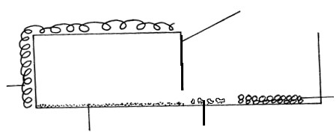

*Moist soil*

*Termites*



*Black*

*paper*



*Dry*

*soil*



*Dark area*



*Lit area*



*card*

*board*

* 1. Predict what happened to the termites after 30 minutes. (1mk)
  2. What form of response is exhibited by termites? (1mk)
  3. State one biological significance of the above response to termites. (1mk)

20. During an ecological study of a lake, a group of students recorded the following observations.

1. Planktonic crustaceans feed on planktonic algae;
2. Small fish feed on planktonic crustaceans, worms and insect larvae;
3. Worms feed on insect larvae;
4. A bird species feeds on small fish, planktonic crustaceans, worms and large fish; (v) Insect larvae feed on planktonic algae; (vi) Large fish feed on small fish.
5. From this record of observations, construct a food web. (4 marks)
6. From the food web, isolate and write down a food chain that ends with:-

(i) Bird species as a secondary consumer. (1 mark) (ii) Large fish as a tertiary consumer. (1 mark)

1. The biomass of the producers in the lake was found to be greater than that of primary consumers. Explain this observation.

(2 marks)

1. Using the food web, identify three pairs of organisms that compete for food in the lake and for each case, name the food being competed for. (6 marks)
2. (i) State three ways by which human beings may interfere with this lake ecosystem. (3 marks)
3. (i) Explain how each of the ways stated in (e) (i) above may affect life in the lake. (3 marks)

21. A person walked bare feet in a swampy area. After a few weeks he started experiencing abdominal pains and diarrhoea. His urine and stool contained blood.

* 1. Name the disease the person was likely to be suffering from and the causative agent of the disease
  2. Disease (1mark)
  3. Causative agent (1mark)

(b.) Apart from avoiding walking bare feet in swampy area. State **two** other ways of controlling the disease. (2marks)

22. State three adaptive features of a desert plant. (3 marks)

23. Equal grams of maize flour were placed into two boxes K and L respectively. Equal numbers of weevils were then introduced into the boxes. The boxes were kept under similar environmental conditions. The weevils were counted at intervals and the results recorded in the table below.

|  |  |  |  |
| --- | --- | --- | --- |
| No. of days after introduction of weevils |  | Approximate No. of weevils present | |
| **K** |  | **L** |
| 0 |  | 20 | 20 |
| 5 |  | 20 | 20 |
| 40 |  | 200 | 300 |
| 60 |  | 550 | 800 |
| 80 |  | 560 | 1300 |
| 100 |  | 650 | 1750 |
| 120 |  | 640 | 1750 |
| 135 |  | 650 | 1740 |
| 150 |  | 645 | 1748 |

a) Using a suitable scale and on the same axes draw two graphs of the approximate number of weevils present against number of days after introduction of weevils on the graph paper provided. (8marks)

(b) What were the approximate number of weevils present in the two boxes on the 70th day? (2marks)

Number in **K:**

Number in **L:**

1. (i) On what day was the population of weevils in **K** 580? (1mark)

(ii) Between which days was the population difference greatest? (1mark)

1. Account for the shape of graph **L** between day 5 and day 100. (4 marks)
2. State factors that would make the human species assume the curve **K**above. (4marks)

24. What is the meaning of the following terms? (2mks)

* 1. Autecology:
  2. Synecology:

|  |  |
| --- | --- |
| 25. (a) Name the causative agent for the following diseases:-  (i) Amoebic dysentery | (1mk) |
| (ii) Schistosomiasis | (1mk) |
| (b) Explain why primary productivity in aquatic environment reduce with increase in depth. | (2mks) |
| (c) Define the term eutrophication. | (1mk) |

26. Use the graph below to answer the questions that follow.

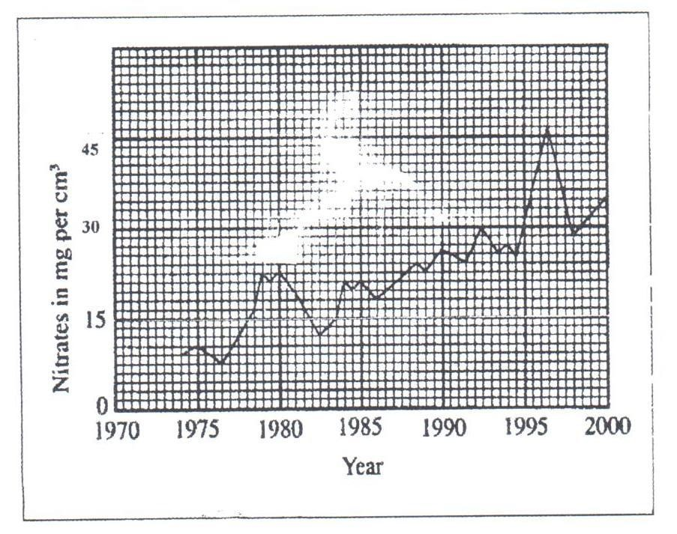

1. Calculate the difference in nitrate concentration between the highest and lowest. (1mk)
2. How can increase in nitrate concentration in the river lead to death of fish? (2mks)
3. Suggest **one** possible sources of nitrate that lead to the pollution in a river. (1mk)

27. (a) A wild beast in Maasai Mara National Park were found to be infested with a lot of ticks. State the trophic level occupied by the following organisms. (2mks)

(i). Wild beast:

(ii). Ticks

(b) Study the food below representing a certain ecosystem and use it to answer the questions that follow.

Locust

Guinea fowl

Grass

Caterpillars

Hawk

Antelopes

Vulture

Lion

1. Write down a food chain in which the vulture is a tertiary consumer. (1mk)
2. What would be the effect of introducing gazelles and termites into the ecosystem? (1mk)

(c) During an ecology, students collected and marked 40 ants and then released them. After 2 days, the students captured another 100 ants, 40 of which had been marked previously.

1. How many ants were there in the compound? Show your working. (2mks)
2. Give **two** assumptions of this method in sampling animal population. (2mks)