* + 1. **[Growth and Development (20 Lessons)](http://www.elimu.net/Secondary/Kenya/KCSE_Student/Biology/Form3/Growth/Growth.htm)**

1. The graph below represents growth of bacteria when cultured in a suitable media.



(

b

)



)

(

a



)

(

c

a)

Name phases labeled A and C.

(2

marks

)

b) Account for the growth of the organism in phase (a) (2marks)

1. What is the importance of laying eggs in long strands of slipperly jelly-like substance in animals that exhibit external fertilisation. (3marks)
2. What is the significance of seed dormancy? (3mks)
3. State **two** advantages of metamorphosis to the life of an insects. (2mks)
4. In an experiment to investigate the effect of heat on germination of seeds, eleven bags each containing 50 bean seeds were placed in a water-bath maintained at 90ºC. After 2 minutes, a bag was removed and the seeds contained in it planted.

The number that germinated was recorded. The procedure used for the beans was repeated for acacia seeds. The results obtained were as shown in the table below.

|  |  |  |
| --- | --- | --- |
| Times  (minutes) | Number of seeds that germinated | |
| Beans seeds | Acacia seeds |
| 0  2  4  6  8  10  12  14  16  18  20 | 50  50  46  35  10  1  0  0  0  0  0 | 0  0  1  2  28  36  41  44  47  48  50 |

1. Using a suitable scale and on the same axes, draw graph of time in hot water against number of seeds that germinated for each plant. (8mks)
2. (i) After how many minutes would you expect 50% of acacia seeds exposed to the hot water to germinate. (1mk)

(ii) What was the minimum number of minutes after exposure of bean seeds to hot water was there no germination? (1mk)

1. From the graphs, which one of the two types of seeds was more sensitive to heat influence on germination? (1mk)

Give a reason for your answer. (1mk)

1. Explain why the ability for the,
   1. bean seeds to germinate decline with time of exposure to heat. (2mks)
   2. acacia seeds to germinate improved with time of exposure to heat. (3mks)
2. What results would be expected if the temperature of water was maintained at:-
3. 100ºC. (2mks)
4. 5ºC. (2mks)
5. (a) Define the term growth. (1 mark)

(b) Name the tissue in plants responsible for:

* 1. Primary growth. (1 mark)
  2. Secondary growth. (1 mark)

1. The diagrams below represents germination in plants.

**A** **B**

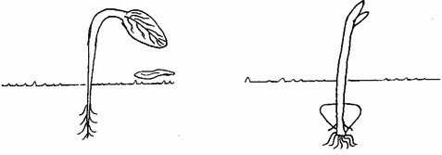

* 1. Name the type of germination in A and B above. (1 mark)
  2. In seed germination, the radicle grows before the shoot. Explain. (2 marks)
  3. Define the term seed dormancy. (1 mark)
  4. State **two** causes of seed dormancy. (2 marks)
  5. State **two** roles of water in seed germination. (2 marks)

1. What is apical dominance (1mark)
2. Distinguish between epigeal and hypogeal germination (2marks)
3. An experiment was set to investigate a certain aspect of response. A seedling was put on a horizontal position as shown in figure M below. After 24 hours, the set up was as shown in figure N.

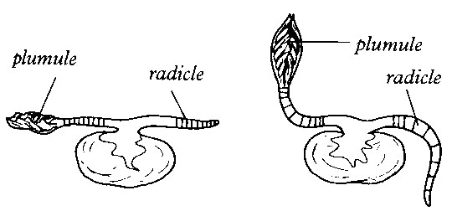

**M**



**N**

|  |  |  |
| --- | --- | --- |
| a) Name the response exhibited. |  | (1mk) |

b) Explain the curvature of the shoot upwards. (3mks)

11. Describe the process of metamorphosis in a grasshopper. (7 marks)

12. State **TWO e**ffects of gibberellins on shoots of plants. (2 Marks)

13. Study the diagrams below and answer the questions that follow.

**A B C**

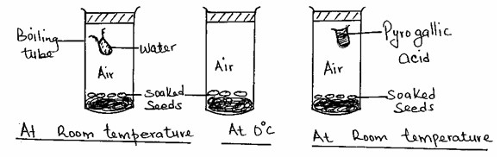

1. Identify the process being investigated. (1mk)
2. With a reason identify the set-up in which germination will occur. (2mks)
3. State **two** roles played by water during germination. (2mks)
4. Name **three** factors inside the seed that causes seed dormancy. (3mks)

14. (a) Explain the role of Auxins in geotropic response in plants (5 marks)

(b) Describe roles of **other** hormones in the growth and development of plants. (15 marks)

15. An experiment was carried out to determine the growth rates of bamboo and a variety of maize plants in two adjacent plots. The average height and average dry weight of plants from the two populations were determined over a period of twenty weeks. The data is as shown in the table below.

|  |  |  |  |  |
| --- | --- | --- | --- | --- |
| Age in weeks | **Bamboo** |  | **Maize** | |
| Average height (Metres) | Average weight (Grams) | Average height (Metres) | Average weight (Grams) |
| 2 | 1.3 | 52 | 0.3 | 20 |
| 4 | 4.0 | 182 | 0.5 | 29 |
| 8 | 8.2 | 443 | 0.8 | 57 |
| 8 | 12.1 | 682 | 1.2 | 78 |
| 10 | 13.9 | 801 | 1.7 | 172 |
| 12 | 14.1 | 957 | 1.9 | 420 |
| 14 | 14.3 | 1025 | 2.1 | 704 |
| 16 | 14.4 | 1062 | 2.1 | 895 |
| 18 | 14.6 | 1127 | 2.1 | 926 |
| 20 | 14.6 | 1229 | 2.1 | 908 |

1. Between which two weeks did the greatest increase in weight occur in: (2mks)
   1. Bamboo plants: (ii) Maize plants:
2. (i) Which of the two types of plants had a higher productivity by the end of the experiment? (1mk) (ii) Give a reason for your answer in (b) (i) above. (1mk)
3. Between weeks 14 and 18, the average height of the maize plants remained constant while average dry weight increased.

Explain this observation. (3mks)

1. Suggest how the change in the average dry weight bamboo and maize plants would have been at week 22 if the experiment was continued. (2mks)
2. Why was it appropriate for this experiment to use:
   1. Dry weight instead of fresh weight. (2mks)
   2. Weight and height. (1mk)
3. Describe how the average height and weight of the plants were determined in this experiment.
   1. Average height. (2mks)
   2. Average dry weight. (3mks)
4. Give a reason why secondary thickening does not occur in bamboo and maize plants. (1mk)
5. Give **two** characteristics of meristematic cells. (2mks)

16. The diagram below shows the difference in growth response to varying hormone concentration by

foot and shoot

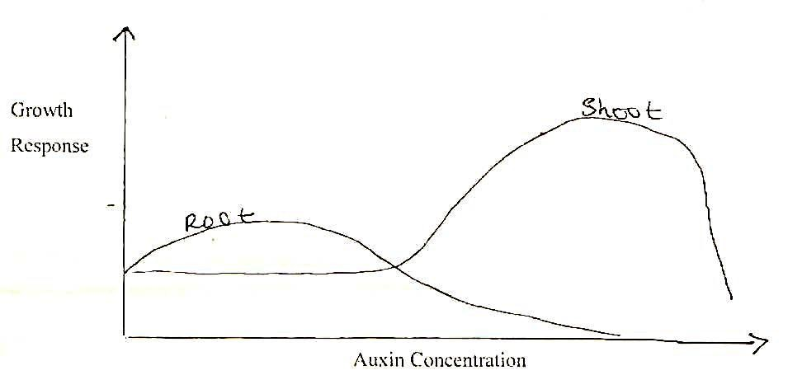

|  |  |  |  |  |
| --- | --- | --- | --- | --- |
| What is the effect of increasing auxin concentration on: |  |  |  |  |
| i) Roots |  |  |  | (1 mark) |
| ii) Shoot |  |  |  | * + - 1. mark) |

17. The set-up was at room temperature for a week

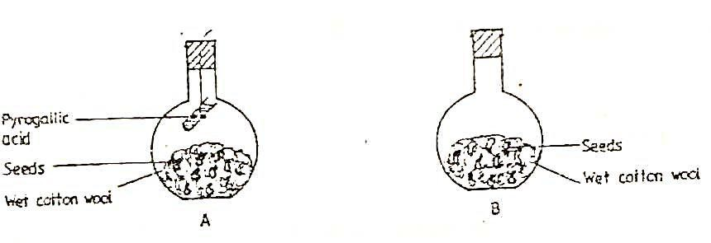

a) What was the aim of the experiment (1 mark)

b) What would be the expected results at the end of the experiment? (2 marks)

1. A small amount of chemical M was put on one side of maize celeoptiles. After some days, it was noted that the celeoptiles curved away from the side to which the chemical was applied.

|  |  |  |  |  |
| --- | --- | --- | --- | --- |
| (a) Suggest the possible identity of chemical substance M |  |  | (1mk) | |
| (b) Explain how this chemical might have caused the celeoptiles to curve. |  |  | (2mks) | |
|  |  |  |  | |
| 19. A student set up an experiment as shown in the diagram below. | | | |  |

### Cotton wool

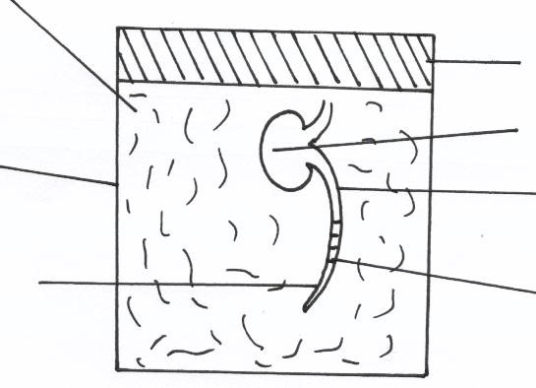

**Glass Container**



**Radicle**



**Marking**



**Bean seedlings**



**Cotyledons**



**Cork**

**AT THE START**

1. (i) What was being investigated in the experiment? (1mk)

(ii) Draw a diagram to indicate the expected results of the experiment after three days. (1mk) (iii) Why was it necessary to have wet cotton wool in the container (1mk)

1. What is the role of the following in a germinating seed?
2. Oxygen (1mk)
3. Cotyledons (1mk)

20. During germination and growth of a cereal, the dry weight of endosperm, the embryo and total dry weight were determined at two – day intervals. The results are shown in the table below.

|  |  |  |  |
| --- | --- | --- | --- |
| Time after planting(days) | Dry weight of endosperm | Dry weight of embryo (mg ) | Total dry weight (mg) |
| 0 | 43 | 2 | 45 |
| 2 | 40 | 2 | 42 |
| 4 | 33 | 7 | 40 |
| 6 | 20 | 17 | 37 |
| 8 | 10 | 25 | 35 |
| 10 | 6 | 33 | 39 |

a) Using the same axes, draw graphs of dry weigh of endosperm, embryo and the total dry weight against time

(8marks)

|  |  |  |  |
| --- | --- | --- | --- |
| b**) What** was the dry weight of the endosperm and embryo on the **5th day?** | |  | (2marks) |
| Endosperm  Embryo  c) **Account** for: |  |
| i) Decrease in dry weight of endosperm from day 0 to 10 |  |  | (2marks) |
| ii) Increase in dry weight of embryo from day 0 day 10 |  |  | (2marks) |
| iii) Decrease in total dry weight from day 0 to day 8 |  |  | (2marks) |
| d) **State** the role of the following in germination   1. Glucose 2. Enzymes |  |  | (2marks) |
| e) **How** are the foliage leaves adapted to their function |  |  | (2 marks) |