* + 1. **[Classification II (35 Lessons)](http://www.elimu.net/Secondary/Kenya/KCSE_Student/Biology/Form3/Classification/Classification.htm)**

1. State **three** similarities between Aves and Pisces (3 marks)

1. Name two kingdoms whose members reproduce by means of spores. (2 marks)
2. The diagram below indicates an organism that grows under shaded places with damp conditions. Study it and answer the

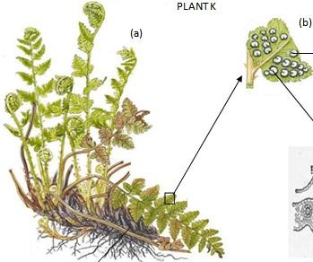

questions that follow.



S



Q



R

* 1. Name the division to which the specimen belongs. (1 mark)
  2. Name the parts labeled Q, R and S. (3 marks)
  3. State the functions of the parts labeled Q and S (2 marks)
  4. Name the two body forms of the organism in its alteration of generations. (2 marks)

1. A student collected a plant with the following features:

* Vascular bundles in the stem were scattered with no cambium.
* Fibrous root system.

Name the sub-division and the class to which the above plant belonged. (2mks) Sub-division Class

1. Write the kingdoms to which the following organisms belong. (3mks)

-Plasmodium

- Bat

-Yeast

1. (i) Name the class in the phylum arthropoda with the largest number of individuals. (1 mark) (ii) State **three** adaptations that makes this class very successful. (3 marks)
2. State three characteristics unique to class Insecta (3marks)
3. The diagram below represents a fern.

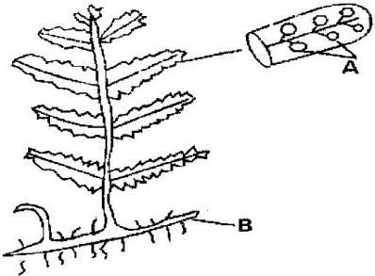

* 1. Name Parts labeled A and B. (2mark)
  2. To which division does the plant belong? (1mark)

1. State three characteristics of members of kingdom Monera that are not found in other kingdoms. (3mk)

10. You are provided with photographs of animals. Study the photographs and the dichotomous key below to enable you identify the taxonomic group to which each animal belongs.

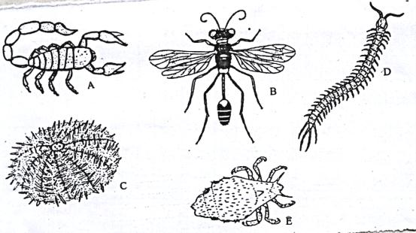

**KEY**

1. a) Jointed legs present ……………………………………………………….……go to 2

b) Jointed legs absent……………………………………………………………..go to 7

2. a) Three pairs of legs …………………………………………………………………....go to 3

b) More than 3 pairs of legs………………………………………………………….go to 5

1. a) Wings present ……………………………………………………………..….go to 4
   1. Wings absent……………………………………………………Anoplura
2. a) One pair of wings…………………………………………………………………Diptera
   1. Two pairs of wings…………………………………………………Hymenoptera

5. a) Four pairs of legs ………………………………………………………………… Arachnida

b) More than ten pairs of legs ………………………………………………………. go to 6

6. a) One pair of legs in each body segment…………………………………………… Chilopoda

b) Two pairs of legs in each body segment …………………………………… Diplopoda

7. a) Body partially enclosed in a shell………………………………………………… Mollusca

b) Body surface has spiny projection…………………………………………….Echinodermata

1. Using the key, identify the following organisms to their taxonomic groups. In each case, give the sequence of steps which you followed in identifying them. (4 marks)

|  |  |  |
| --- | --- | --- |
| Animal | Identity | Steps followed |
| A |  |  |
| B |  |  |
| D |  |  |
| E |  |  |

1. i) Using observable features only, state the class to which the animal labeled A and B on the photographs above belong (2 marks)

State two observable features on B, that enabled you to arrive at that answer in (b (i) above. (2marks)

11. The drawing shows a bacterial cell.

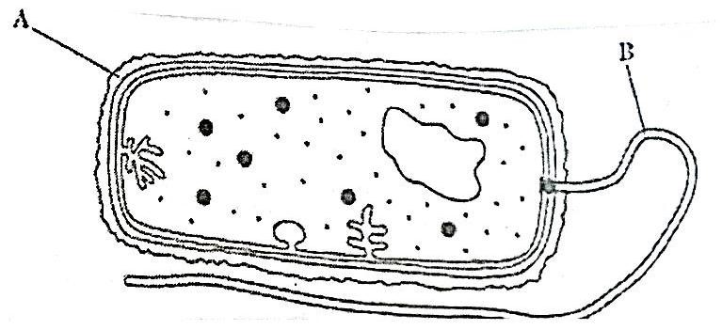

1. Name structures A and B. (2marks)
2. State the kingdom to which the cell above belongs. (1marks)
3. Give two observable reasons for your answer. (2marks)

|  |  |
| --- | --- |
| 12. Study the diagram and answer the questions that follow.    (a) State the division the organism belongs. | (1mk) |
| (b) Name the part labelled K. | (1mk) |
| (c) What is the function of the part labelled M? | (1mk) |

13. Study the diagram below of an organism and answer the questions below it.

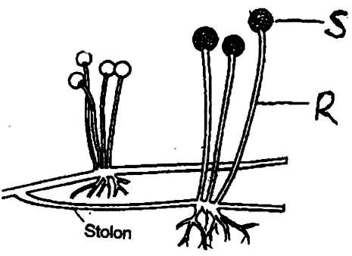

|  |  |
| --- | --- |
| (i) (i) Name the part labeled R on the diagram. | (1mk) |
| (ii) State the function of part S. | (1mk) |
| (ii) (i) Identify the kingdom to which it belongs. | (1mk) |
| (ii) Give a reason for your answer in (a) (i) above. | (1mk) |
| (iii) (i) State the asexual mode of reproduction of the organism shown in the diagram. | (1mk) |
| (ii) Identify **two** other asexual modes of reproduction among lower organisms. | (2mks) |
| (iv) Name the structure in which male gametes are produced in division Bryophyta.   1. Name the division of the Kingdom plantae with the following spore producing bodies.   (i) Sori  (ii) Capsule | (1mk) |

15. Below is a diagram of a plant a form three student collected while carrying out an ecological study?

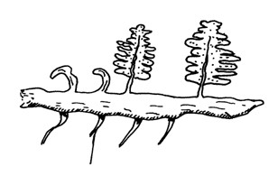

*Adventitious root*

a) With reasons identify the division into which the students classified the plant.

|  |  |
| --- | --- |
| b) (i) **Name** the structure that produces spores in this plant. | (1mark) |
| (ii) State **two** differences between the plant division above and that of the division *spermatophyta.* | (2 marks) |

c) Give **two** distinguishing features of class *Amphibia* (2marks)

16. In a tabulated form, distinguish between class gymnospermae and angiospermae. 2mks

17. Study the diagram of the organism shown below then answer the questions that follow.

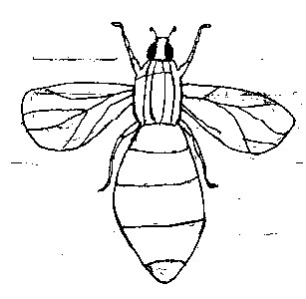

* 1. State the phylum to which the organism belongs. 1mk
  2. With reasons state the class to which the organism belongs:-

Class 1mk

Reasons: 3mks

(c) Name two human diseases of which the organism is a vector. 2mks

(d) What type of metamorphosis does the organism show? 1mk

18. A student observing a drop of water under the power objective lens of a microscope observed an

organism and drew the following organism.

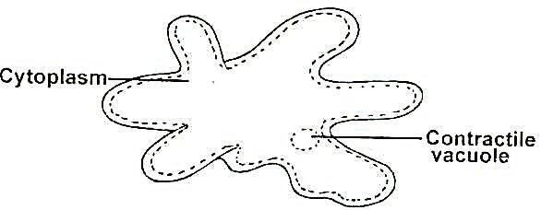

* 1. Suggest the kingdom to which the organism belongs. (1mark)
  2. Identify the organism (1mark)
  3. Give an example of a disease caused by the organism. (1mark)

19. Study the diagram below and answer the questions that follow.

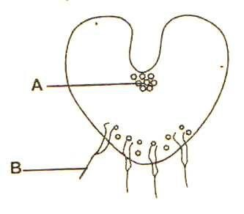

Name the parts labeled A and B. (2marks)

20. (i) State **one** characteristic shared by the class Reptilia and class Aves. (1mk)

(ii) Some students collected a living specimen for use in the laboratory. It had the following characteristics:

-Two pairs of legs per segment

-Elongated body

- Body has between 9- 100 segments

- Three body parts

Which class does the above animal belong? (1mk)