**[12.0.0 Reproduction in Plants and Animals (50 Lessons)](http://www.elimu.net/Secondary/Kenya/KCSE_Student/Biology/Form3/Reproduction/Reproduction.htm)**

1. What are the functions of amniotic fluid?

2. The diagram below shows a structure in flowering plants.



**B**



**A**

State the function of each of the following parts labeled A and B after double fertilization. (2 marks)

3. Below is across section of a fruit.

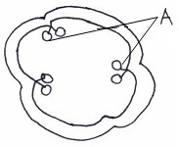

* 1. Name the type of placentation shown. (1mk)
  2. Identify the parts labelled **A**. (1mk)

4. Below is a diagram of a mature embryo sac.

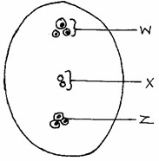

1. Name the parts labelled.
   1. **W** …………………………………………………………….. (1 mark)
   2. **Z** ……………………………………………………………… (1 mark)
2. Give the name of the part of the seed formed when the part labelled **X** fuses with one of the male nucleus. (1 mark)

5. State the functions of the following male hormones.

(a) Follicle stimulating hormone. (1 mark)

(b) Luteinizing hormone. (1 mark)

6. The hormone Human Chorionic Gonadotrophin (HCG) is released from embryonic tissues. The effects of HCG is to prevent the degeneration of corpus luteum. Study the table below, which shows changes in concentration in the blood of HCG and progesterone during the first 36 weeks of pregnancy.

|  |  |  |
| --- | --- | --- |
| Time in weeks | Concentration of HCG (arbitrary units) | Concentration of progesterone (arbitrary units) |
| 0  2  4  8  12  16  20  24  28  32  36 | 0  3  15  60  45  24  12  10  10  14  12 | 7  7  8  9  10  11  13  15  20  30  55 |

1. Using the grid provided, plot graphs of concentration of HCG and progesterone produced against time. (8 marks)
2. (i) What is the concentration of HCG progesterone in week 11? (2 marks)
   1. When are the two hormones equal in concentration? (2 marks)
   2. Account for the changes in HCG concentration during the first 20 weeks of pregnancy. (4 marks)
3. State **three** functions of progesterone. (3 marks)
4. What is the role of testosterone in a human male? (1 mark)

7. a) Why does a membrane form around the egg after fertilization? (1mark)

* 1. Give three differences between an egg and a sperm (3marks)

8. Describe what happens when the pollen tube enters the embryo sac (3marks)

9. State two ways by which human immune deficiency Virus (HIV) is transmitted. (2marks)

10. The figure below shows the embryo-sac before fertilization.

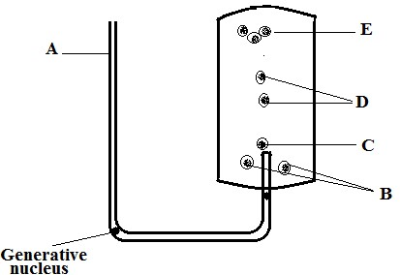

|  |  |  |
| --- | --- | --- |
| 1. Identify the structures labeled A and B. 2. Identify the structures labelled in the diagram that will develop into the following after fertilization. |  | (2marks) |
| (i) Embryo |  | (1 mark) |
| (ii) Endosperm  (c) State the ploidy of each the following nucleic after fertilization |  | (1 mark) |
| (i) C |  | (1 mark) |
| (ii) D |  | (1 mark) |

(d) Briefly outline the process of “double “fertilization in the flowering plants. (2marks)

11. Explain various ways in which fruits and seeds are adapted to dispersal. (20 marks)

12. Explain how the following factors hinder self pollination in plants:

* + 1. Protogyny (1mark)
    2. Dioecism (1mark)

13. The diagram below shows a stage during fertilization in flowering plant.

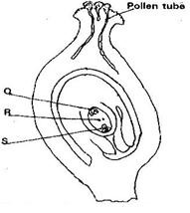

* 1. Name the parts labeled Q, R, and S. (3 mk)
  2. State the function of the pollen tube. (1 mk)

14. (a) What is the disadvantage of self- pollination in plants? (1mark)

(b) State **two** features that discourage self-pollination. (2marks)

15. The diagram below shows a cross – section through a pistil.

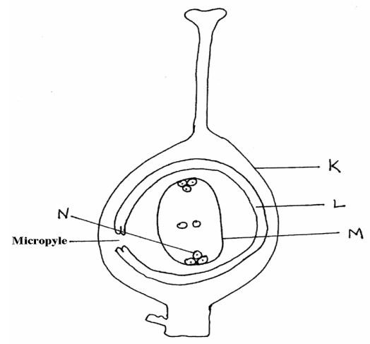

(a) Name the structures labeled K, L and M: (3 marks)

(b) What do the following parts develop into after fertilization?: (2 marks) Part L:

Part N:-

(c) State three ways by which plants promote cross fertilization. (3 marks)

16. (a) State why the placenta is considered as an endocrine gland. (1mk)

* 1. Describe how the embryo in human is protected during pregnancy. (2mks)

|  |  |
| --- | --- |
| 17. The diagram below shows a seed of a certain plant.    (a) Name the likely agent of dispersal. | (1mk) |
| (b) Give a reason for your answer. | (1mk) |

18. A flower was found to have the following characteristics

* Inconspicuous petals
* Long feathery stigma
* Small light pollen grains
  1. What is the likely agent of pollination of the flower? (1 mark)
  2. What is the significance of the long feathery stigma in the flower (1 mark)

19. State the function(s) of the following cell structures during cell division. (2mks)

(i) Centriole

(ii) Centromere

|  |  |
| --- | --- |
| 20. (a) Explain how the following parts of a mammalian reproductive system are adapted to their functions. i) Testis  ii) Uterus | (2mks) |
| (b) Explain why removal of the ovary after four months of pregnancy does not terminate pregnancy. | (1mk) |