**Name…………………………………………………………… ADM. Number: …………….**

**School: …...………....................................... Candidate’s Signature ……………...…………..**

**121/1**

**Mathematics Alt. A**

**FORM THREE.**

**OCTOBER 2022.**

**2 ½ Hours.**

**URANGA MATHEMATICS ASSOCIATION-2022.**

**Kenya Certificate of Secondary Education**

**MATHEMATICS**

**121/1**

**FORM THREE**

**TIME: 2 ½ HOURS**

**INSTRUCTIONS TO CANDIDATES:**

* Write your name, school, admission number and sign in the spaces provided above.
* This paper contains **TWO** sections: Section **I** and Section **II**.
* Answer **ALL** the questions in Section **I** and **FIVE** questions from section **II**.
* All answers and working **MUST** be written on the question paper in the spaces provided below each question.
* Marks may be given for correct working even if the answer is wrong.
* Non-programmable silent electronic calculators and KNEC Mathematical tables may be used, except where stated otherwise.

**FOR EXAMINERS USE ONLY**

**SECTION I**

|  |  |  |  |  |  |  |  |  |  |  |  |  |  |  |  |  |
| --- | --- | --- | --- | --- | --- | --- | --- | --- | --- | --- | --- | --- | --- | --- | --- | --- |
| **1** | **2** | **3** | **4** | **5** | **6** | **7** | **8** | **9** | **10** | **11** | **12** | **13** | **14** | **15** | **16** | **Total** |
|  |  |  |  |  |  |  |  |  |  |  |  |  |  |  |  |  |

**SECTION II**

**Grand Total**

|  |  |  |  |  |  |  |  |  |
| --- | --- | --- | --- | --- | --- | --- | --- | --- |
| **17** | **18** | **19** | **20** | **21** | **22** | **23** | **24** | **Total** |
|  |  |  |  |  |  |  |  |  |

*This paper consists of 15 printed pages. Candidates should check to ascertain that all pages are printed as indicated and that no questions are missing.*

***SECTION I (50MARKS)***

***Answer all the questions in this section in the spaces provided.***

1. Without using calculator, evaluate (3 marks)



2. Solve for the value of x in  (3 marks)

3. Agnes paid rent which was $\frac{1}{10}$ of her net salary. She used $\frac{1}{2}$ of the remaining amount to make a

down payment for a plot. She gave her mother sh. 2500 and did shopping worth sh. 7500 for

herself. She saved the remaining which was sh. 12,500. How much was the down payment

that she made? (4 marks)

4. A tourist arrived in Kenya with U$ 10,000. He exchanged all the money into Kenya shillings

and spent half of the money in the country and exchanged the remaining to South African

rand. Use the table below to calculate the amount of money he got in rands. (3 marks)

Buying selling

1 U$ dollar 109.35 110.20

1 SA rand 9.55 10.05

5. Each exterior angle of a regular polygon is a fifth of the interior angle.

1. Find the size of the exterior angle (2 marks)
2. Find the number of sides of the polygon (2 marks)

6. Solve for in the equation (3 marks)

7. Given that **OA** = -3*i* + 5j and **OB** = 2*i –* 2*j.* Find the magnitude of **AB** to one decimal

place. (3 marks)

8. The heights of two similar pails are 12cm and 8cm. The larger pail can hold 2 litres. What is

the capacity of the smaller pail? (3 marks)

9. Simplify the expression (3 marks)

P2 – 4m2

2m2 – 7mp + 3p2

10. A is a reflex angle and tan A = . Determine the value of Cos A without using the

Mathematical table or calculator. (3 marks)

11. a) Sketch the net of a wedge in the following figure. (2 marks)

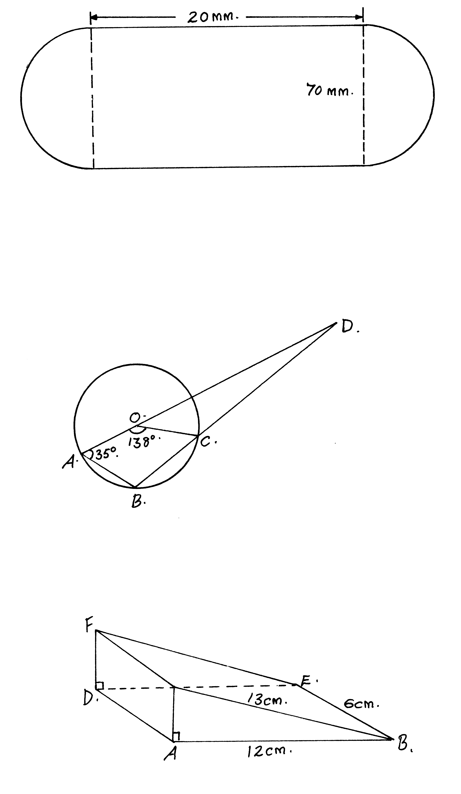

b) Calculate the surface area of the net drawn above. (2 marks)

12. Express the inequalities  in the form p ≤ x ≤ q hence state the

integral values (3 marks)

13. A train of length 80m crosses a bridge 20 m long in 5 seconds. Calculate the average speed

of the train in km/h (3 marks)

14. A solid block in the shape of a cylinder has a height of 14cm and weighs 22kg. If it is made of material of density 5g/cm3, find the radius of the cylinder. Take π= (4 marks)

15. Use the reciprocal, square and square-root tables to evaluate to 4 significant figures the expression.

 (4 marks)

16. Without using a calculator or tables, find the value of y given that y = (a+b) (x – c) 2 and a = 5, b =6, x = -3 and c = 2. (2 marks)

**SECTION II: (50 MARKS)**

***Answer any five questions in the section in the spaces provided***

17. Below shows two circles, Centre A and B which intersect at points P and Q.

Angle PAQ = 600, angle PBQ = 300 and PA = AQ = 10cm.

**P**

**B**

**300**

**600**

A

**Q**

Use the diagram to calculate

1. PQ to correct to 2 decimal places (2 marks)
2. PB correct to 2 decimal places (2 marks)
3. Area of the minor segment of the circle whose centre is A (2 marks )
4. Area of shaded region (4 marks)

18.A matatu and Nissan left town A for town B 240km away at 8.00a.m travelling at 90km/hr and 120km/hr respectively. After 20 minutes the Nissan had a puncture which took 30 minutes to mend.

a) How far from town A did the Nissan catch up with the matatu? (6 marks)

b) At what time did the Nissan catch up with the matatu? (2 marks)

c) At what time did the matatu reach town B? (2 marks)

19. Four cities **A**, **B,C,** and **D** are such that town **B** is 1500km due East of town **A**. Town **C** is

1800km due North of town **B**. Town **D** is on a bearing of 3300 from town **A** and on a bearing

of 3000 from **C**.

1. Use a ruler and compasses only to show the position of town **A, B, C, D**

**(**Take a scale of 1cm = 300km**)** (5 marks)

1. Determine

(i) The distance **AD**. (2 marks)

(ii) The distance **CD**  (2 marks)

(iii) The bearing of town **D** from town **B**. (1 mark)

20. Triangle ABC vertices A (-2, 6), B (2, 3) and C (-2, 3) is reflected in the line x = -3 to give the image A1B1C1 . A1B1C1 is translated by the vector $\left(\begin{matrix}10 \\ 2\end{matrix}\right)$ to give image A2B2C2. A3B3C3 with coordinates A3 (6,-6) B3 (2,-3) and C3 (6,-3) is the image of A2B2C2 after another transformation.

a) Plot all the triangles in the grid provided. (6 marks)

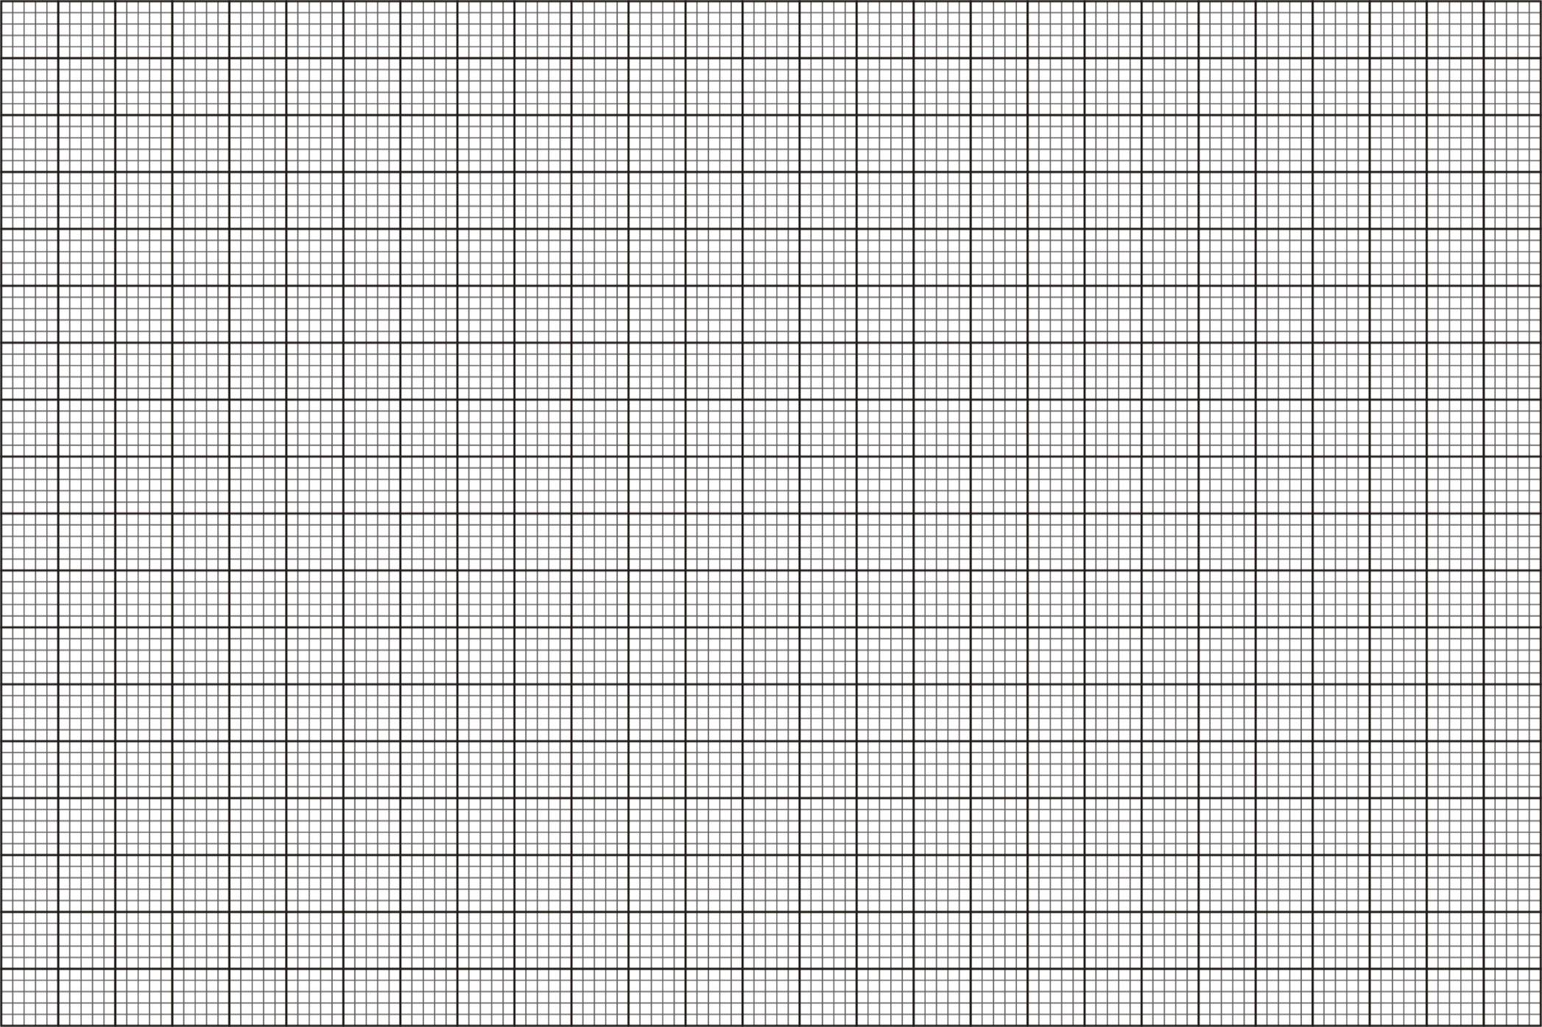

b) Determine the transformation that maps:

(i) A2B2C2 onto A3B3C3 (2 marks)

(ii) ABC onto A3B3C3 (2 marks)

21. In the given figure, ∠CAD = 50°, ∠BEC = 75° and ∠BDC = 25°. BAF is a straight line.

B

C

A

D

F

50°

25°

75°

E

Giving reasons in each case, calculate the size of:-

(i) ∠ABC. (2 marks)

(ii) ∠DEC. (2 marks)

(iii) ∠ABD. (3 marks)

(iv) ∠DAF. (3 marks)

22. The masses of a number of form one students in Rateng mixed secondary school were

measured to the nearest kilogram and recorded in the table below.

40 39 37 41 43 41 43 38 40 43

45 42 47 48 46 49 50 53 46 47

39 44 48 51 46 46 54 45 44 46

50 54 52 47 52 51 53 49 44 52

46 43 50 49 48 47 46 48 51 41

1. Use the above data to complete the frequency table below (4 marks)

|  |  |  |  |
| --- | --- | --- | --- |
| **Class (kgs)** | **Frequency (f)** | **Mid-point (x)** | **Fx** |
| 37-39 | 4 | 38 | 152 |
| 40-42 | 6 |  |  |
| 43-45 |  |  |  |
| 46-48 | 15 | 47 | 705 |
| 49-51 | 10 |  |  |
| 52-54 | 6 |  |  |

∑f= ∑fx=

1. Find the modal class (1 mark)
2. Use the completed table to calculate:
3. The mean mass (2 marks)
4. The median mass (3 marks)

23.

B

x + y = 8

x – y = 6

C

x

O D E

A

The diagram above represent Cartesian plane.

Determine the:

1. Coordinates of points A. (2 marks)
2. Coordinates of points C. (3 marks)

1. If a line passes through the point C and the origin, find the equation of the line.

(3 marks)

1. Coordinates of point D. (1 mark)
2. Coordinates of point E. (1 mark)

24. A group of teachers decided to raise Ksh. 144,000 to buy a plot of land. Each teacher was to

contribute the same amount. Before the contributions were made five of the teachers retired.

The remaining teachers had each to contribute more by Ksh. 2,400 to meet their target.

If there were x teachers originally.

1. Write down an expression for the amount that teachers were to contribute originally.

(1 mark)

1. Write down an expression for the amount that each teacher was to contribute after five teachers retired. (1 mark)
2. Write down an equation in x and solve for x. (5 marks)
3. Calculate the percentage increase of the contribution per teacher. (3 marks)