**Name………………………………………… ADM Number:…………………….…............**

**School:…...……….............................................................. Candidate’s Signature…………….**

**121/1**

**Mathematics Alt.A**

**FORM TWO.**

**June 2022.**

**2 ½ Hours.**

**URANGA MATHEMATICS ASSOCIATION-2022.**

**Kenya Certificate of Secondary Education**

**MATHEMATICS**

**121/1**

**FORM TWO.**

**TIME: 2 ½ HOURS**

**INSTRUCTIONS TO CANDIDATES:**

* Write your name, school, admission number and sign in the spaces provided above.
* This paper contains **TWO** sections: Section **I** and Section **II**.
* Answer **ALL** the questions in Section **I** and **FIVE** questions from section **II**.
* All answers and working **MUST** be written on the question paper in the spaces provided below each question.
* Marks may be given for correct working even if the answer is wrong.
* Non-programmable silent electronic calculators and KNEC Mathematical tables may be used, except where stated otherwise.

**FOR EXAMINERS USE ONLY**

**SECTION I**

|  |  |  |  |  |  |  |  |  |  |  |  |  |  |  |  |  |
| --- | --- | --- | --- | --- | --- | --- | --- | --- | --- | --- | --- | --- | --- | --- | --- | --- |
| **1** | **2** | **3** | **4** | **5** | **6** | **7** | **8** | **9** | **10** | **11** | **12** | **13** | **14** | **15** | **16** | **Total** |
|  |  |  |  |  |  |  |  |  |  |  |  |  |  |  |  |  |

**SECTION II**

**Grand Total**

|  |  |  |  |  |  |  |  |  |
| --- | --- | --- | --- | --- | --- | --- | --- | --- |
| **17** | **18** | **19** | **20** | **21** | **22** | **23** | **24** | **Total** |
|  |  |  |  |  |  |  |  |  |

*This paper consists of 15 printed pages. Candidates should check to ascertain that all pages are printed as indicated and that no questions are missing.*

**SECTION I (50MARKS)**

***Answer ALL question in this section in the space provided***

1. a) Evaluate  (2 mark)

b) Write the total value of the 3rd digit the results obtained in (a) above (1 mark)

1. Work out without using tables or calculator giving the answer as a mixed number in its simplest form. (3 marks)



1. Given that , find the values of *x* and *y* (3 marks)
2. Use logarithm tables to evaluate,  (4 marks)
3. Without using a calculator evaluate,  (3 marks)
4. The sum of two numbers is 15. The difference between five times the first number and three times the second number is 19. Find the two numbers (3 marks)
5. A farmer feeds every two cows on 480 kg of hay for four days. The farmer has 20160 kg of hay which is just enough to feed his cows for 6 weeks. Find the number of cows in the farm (3 marks)
6. A salesman is paid a salary of Ksh 15,375 per month. He also gets a commission of 41/2 % on the amount he makes for his sales. In a certain month, he earned a total of Ksh 28875. Calculate the value of his sales that month (3 marks)
7. The size of an interior angle of a regular polygon is 3ο while its exterior angle is ο. Find the number of sides of the polygon. (3 marks)

1. During a certain month, the exchange rates in a bank were as follows;

|  |  |  |
| --- | --- | --- |
|  | Buying (Ksh.) | Selling (Ksh.) |
| 1 US $ | 91.65 | 91.80 |
| 1 Euro | 103.75 | 103.93 |

A tourist left Kenya to the United States with Ksh.1 000,000.On the air port he exchanged all the money to dollars and spent 190 dollars on air ticket. While in US he spent 4500 dollars for upkeep and proceeded to Europe. While in Europe he spent a total of 2000 Euros. How many Euros did he remain with? (3marks)

1. Solve for X in the equation. (3marks)



12. Hawk Aircraft Company bought seven Tornado Aircrafts for eighteen billion, nine hundred and seventy five million, twenty eight thousand, two hundred and forty.

(a) Write the total cost of the seven aircrafts in figures. (1 mark)

(b) Calculate the cost of each aircraft. (2 marks)

13. An ant moved from Y to X the midpoint of RS through P in the right pyramid below

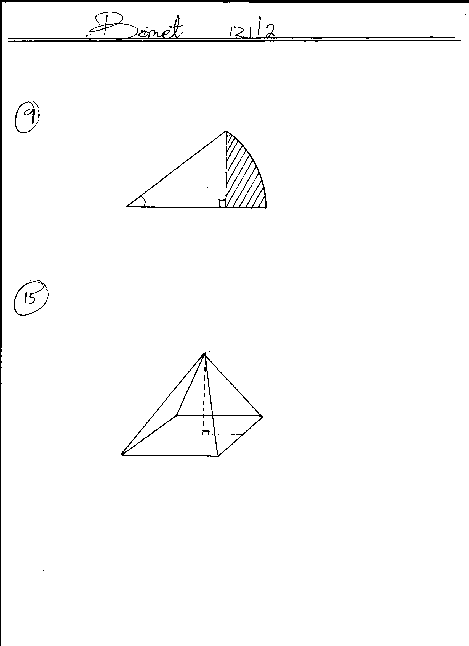

**Y**

**15cm**

**•**

**•**

**O**

**12cm**

**R**

**Q**

**P**

**S**

**8cm**

**X**

O

Draw the net of the pyramid showing the path of the ant hence find the distance it moved. (4marks)

1. Melisa ate 1/5 of her birthday cake and gave 2/3 of the remainder to her friends. The rest was kept for her two sisters who were absent. If the two sisters shared their piece equally, what fraction of cake did each sister eat? (3 marks)

1. Mr. Ombogo the principal of Chiga secondary would wish to cover the floor of the new administration block using the square tiles. The floor is a rectangle of sides 12.8m by 8.4m. Find the area of each of the largest tiles which can be used to fit exactly without breaking. (3 marks)

1. Use tables of cubes and reciprocals to evaluate giving your answer to 2dp. (3 marks)

$${0.98567}^{3}+ \frac{6}{0.0567}$$

**SECTION II (50MARKS)**

***Answer FIVE questions in the spaces provided.***

17. The following measurements were recorded in a field book of a farm in metres

(XY=400m)

|  |  |  |
| --- | --- | --- |
| C 60  B 100  A 120 | Y  400  340  300  240  220  140  80  X | 120 D  100 E  160 F |

1. Using a scale of 1cm representing 4000 cm, draw an accurate map of the farm (5marks)
2. If the farm is on sale at kshs.80,000.00 per hectare, find how much it costs. (5 marks)

18. (a). Use graphical method to solve the following simultaneous equations. (7 marks)

y – 1 = 2x

-4y + 3x = 1

(b). Use elimination method to solve the equations in (a) above. (3 marks)

19. A bookstore has 30 816 exercise books which were packed in cartons. Each carton contained

24 exercise books. The mass of an empty carton was 2kg and that of a full carton is 12kg.

1. How many cartons were there? (2 marks)
2. What was the total mass of the empty cartons? (2 marks)
3. What was the total mass of books in one carton? (2 marks)
4. What was the total mass of all the exercise books? (2 marks)
5. What was the mass of one exercise book in kg to 2 decimal places? (2 marks)

20. Three warships P, Q and R are at sea such that ship Q is 400km on a bearing of 0300 from ship P. Ship R is 750 km from ship Q and on a bearing of 1200 from ship Q. An enemy ship S is sighted 1000km due south of ship Q.

1. Taking a scale of 1cm to represent 100km, locate the relative positions of ships P, Q, R and S. (4 marks)
2. Find the compass bearing of;
3. P from S (2 marks)
4. S from R
5. Use the scale drawing to determine the distance of:
6. S from P (2 marks)
7. R from S
8. Find the bearing of:
9. Q from R (2 marks)
10. P from R

21. (a) Draw triangle ABC in which AB = 11cm, AC = 8cm and BC = 5.6cm. (2 marks)

(b) Construct the bisectors of any two angles of the triangle and let the bisectors meet at R. (2 marks)

(c) Draw the perpendicular from R to AB so that it cuts AB at M. (2 marks)

(d) With centre R and the radius RM, Draw a circle. (2 marks)

(e) Calculate the area of the circle. (2 marks)

22. A carpenter constructed a closed wooden box with internal measurements 1.5m long by 0.8m

wide and 0.4m high. The wood used in constructing the box was 1.0cm thick and had a

density of 0.6 g/cm3.

1. Determine the:
2. Volume in cm3 of the wood used in constructing the box. (3 marks)
3. Mass of the box in kg correct to 1dp. (2 marks)
4. Identical cylindrical tins of diameter 10cm and height 20cm with a mass of 120g each were packed in the box. Calculate;
5. Maximum number of tins that were packed in the box. (3 marks)

1. Total mass of the box with the tins. (2 marks)

23. Three business partners Kamau, Tatua and Makau contributed Ksh. 100 000, Ksh. 80 000 and Ksh. 50 000 respectively to start a business. After one year the business realized a profit which they shared in the ratio of their contribution.

1. If Makau’s share of profit sh. 20 000 how much was the total amount of profit?

(3 marks).

1. At the beginning of the second year Makau boosted his shares by sh. 10 000. If the business profit was increased by 20% at the end of the second year. Calculate:
2. Kamau’s share of the profit. (4 marks).
3. The difference between Kamau’s share and Tatua’s share of profit. (3 marks)

24.Two cubes of length 5cm and 7cm are melted and cast into a single cube.

Determine the:

1. Volume of the new cube. (3 marks)

1. Length of the new cube correct to 1 decimal place . (2 marks)
2. Surface area of the new cube. (2 marks)
3. Suppose that it was instead cast into a cylinder of radius 3.5 cm. what would the height be to the nearest cm? Take $π=\frac{22}{7}$. (3 marks)