**FORM 3 EVALUATION TEST  
BIOLOGY END TERM 1 2020  
NAME……………………..……………………………. DATE…………………………**

***Answer all the questions in the spaces provided***

1. Insects’ blood is noted to lack a respiratory pigment. Explain (1 mark)

………………………………………………………………………………………………………………………………………………………………………………………………………………………………………………

1. State the function of the following parts of a nephron.
2. Loop of Henle (1 mark)

………………………………………………………………………………………………………………………………………………………………………………………………………………………………………………

1. Distal convoluted tubule. (1 mark)

………………………………………………………………………………………………………………………………………………………………………………………………………………………………………………

1. Most terrestrial plants do not grow well in water logged soils. Give a reason for this (1mark)

………………………………………………………………………………………………………………………………………………………………………………………………………………………………………………

1. Give two destinations of food translocated from the leaves of plants. (2 marks)

………………………………………………………………………………………………………………………………………………………………………………………………………………………………………………

1. Name the organelle that is likely to be found in abundance in:
2. An enzyme secreting cell.

………………………………………………………………………………………………………………………

1. Cells producing lipid related secretions.

………………………………………………………………………………………………………………………

1. Areas where the cells have ruptured

………………………………………………………………………………………………………………………

1. A small boy remarked that his dog looks larger on cold days than on hot days. Give a biological explanation for this. (2 marks)

………………………………………………………………………………………………………………………………………………………………………………………….………………………..………………………….

1. The table below shows the percentage composition of carbon (IV) oxide and oxygen in inhaled and exhaled air.

|  |  |  |
| --- | --- | --- |
| Gases | Inhaled air | Exhaled air |
| Oxygen | 20 % | 17% |
| Carbon (IV) oxide | 0.04% | 4.0% |

Explain the differences in percentage of the two gases in inhaled and exhaled air.

1. Oxygen (2 marks)

………………………………………………………………………………………………………………………………………………………………………………………….………………………..………………………….

1. Carbon (IV) oxide (2 marks)

………………………………………………………………………………………………………………………………………………………………………………………….………………………..………………………….

1. The diagram below represents a pyramid of biomass derived from a certain ecosystem.

Consumer

Producer

1. Suggest the type of ecosystem from which the pyramid was derived (1 mark)

………………………………………………………………………………………………………………………………………………………………………………………….………………………..………………………….

1. State the significance of short food chains in an ecosystem. (1 mark)

………………………………………………………………………………………………………………………………………………………………………………………….………………………..………………………….

1. Distinguish precisely between diabetes mellitus and diabetes insipidus ( 2 marks)

………………………………………………………………………………………………………………………………………………………………………………………….………………………..………………………….

1. The set up below shows apparatus to demonstrate a certain biological process

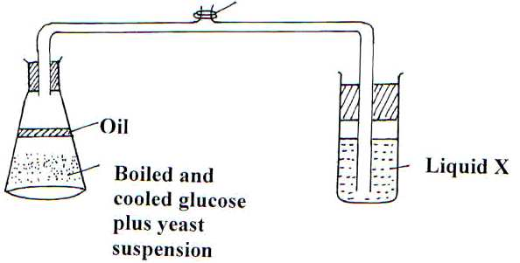

1. What biological process was being investigated in the experiment (1 mark)

……………………………………………………………………………………………………………………………………………………………………………………….…………………………..………………………….

1. Write down a word equation that represents the reaction above. (1 mark)

……………………………………………………………………………………………………………………………………………………………………………………….…………………………..………………………….

1. State two functions of the spleen (2 marks)

……………………………………………………………………………………………………………………………………………………………………………………….…………………………..………………………….

1. Name the excretory products eliminated by the following animals.
2. Tilapia. (1 mark)

………………………………………………………………………………………………………………………………………………………………………………………………………………………………………………

1. Chicken. (1mark)

………………………………………………………………………………………………………………………………………………………………………………………………………………………………………………

1. State the functions of the following parts of the human ear. (1mark)
2. Ossicles (1mark)

………………………………………………………………………………………………………………………………………………………………………………………………………………………………………………

1. Pinna (1mark)

………………………………………………………………………………………………………………………………………………………………………………………………………………………………………………

1. Name the causative organism of the following diseases.
2. Malaria (1mark)

………………………………………………………………………………………………………………………………………………………………………………………………………………………………………………

1. Bilharzias (1mark)

………………………………………………………………………………………………………………………………………………………………………………………………………………………………………………

1. Identify the part of light microscope which serve each of the functions described below
2. Making rough focus ( 1mark)

………………………………………………………………………………………………………………………………………………………………………………………………………………………………………………

1. Reflecting light from the source (1 mark)

………………………………………………………………………………………………………………………………………………………………………………………………………………………………………………

1. State two characteristics of aerenchyma tissue. (2marks)

………………………………………………………………………………………………………………………………………………………………………………………………………………………………………………

1. What is the significance of transpiration in plants? (3marks)

………………………………………………………………………………………………………………………………………………………………………………………………………………………………………………………………………………………………………………………………………………………………………………………………………………………………………………………………………………………………

1. State two ways in which xylem vessels are adapted to their functions. ( 2marks)

………………………………………………………………………………………………………………………………………………………………………………………………………………………………………………………………………………………………………………………………………………………………………………………………………………………………………………………………………………………………

1. State the characteristics that distinguish the following organisms into their respective classes (3 marks)

Millipedes, spider and tsetse fly.

………………………………………………………………………………………………………………………………………………………………………………………………………………………………………………………………………………………………………………………………………………………………………………………………………………………………………………………………………………………………

1. How do identical twins and fraternal twins arise?
2. Identical twins (2 marks)

………………………………………………………………………………………………………………………………………………………………………………………………………………………………………………

1. Fraternal twins. (2 marks)

………………………………………………………………………………………………………………………………………………………………………………………………………………………………………………

1. 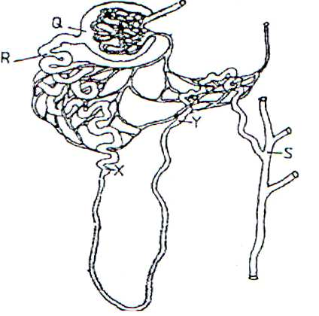The diagram below illustrates part of a nephron from a mammalian kidney.
2. Name the fluid found in the part labeled Q. (1 mark)

………………………………………………………………………………………………………………………………………………………………………………………………………………………………………………

1. Identify the process responsible for the formation of the fluid named in (a) above (1mark)

………………………………………………………………………………………………………………………………………………………………………………………………………………………………………………

1. Which two hormones exert their effect in the nephron? (2 marks)

………………………………………………………………………………………………………………………………………………………………………………………………………………………………………………

1. The experiment illustrated below was set up to investigate a certain physiological process using a raw tuber.

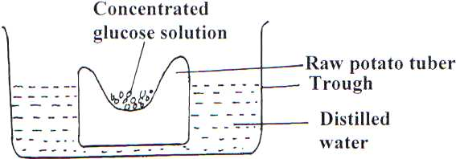

1. Suggest a possible physiological process that was being investigated. (1 mark)

………………………………………………………………………………………………………………………………………………………………………………………………………………………………………………

1. Explain the results obtained in the above experiment after a few hours (2 marks)

………………………………………………………………………………………………………………………………………………………………………………………………………………………………………………

1. State the observations that would have been made if the experiment was repeated using boiled potato.

………………………………………………………………………………………………………………………………………………………………………………………………………………………………………………

1. (a) Give two functions of blood as a tissue. (2 marks)

………………………………………………………………………………………………………………………………………………………………………………………………………………………………………………

1. 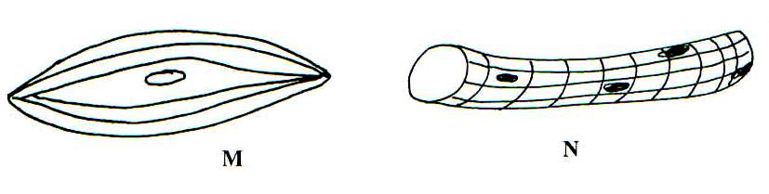The figures below illustrate specialized cells in an animal body.
2. Identify the cells M and N (2 marks)

M

………………………………………………………………………………………………………..…….

N

………………………………………………………………………………………………………………

1. State the structural differences between M and N (2marks)

………………………………………………………………………………………………………………………………………………………………………………………………………………………………………………

1. Which of the above specialized cells is found in the gut? (1mark)

………………………………………………………………………………………………………………………………………………………………………………………………………………………………………………

***MARKING SCHEME***

***BIOLOGY FORM 3 TERM 1 2020***

1. Insects blood is not used for transportation of respiratory gases.

2. (i) Reabsorption of salts.

(ii) Reabsorption of water.

3. ✓ To roots/stems for storage.

* Oxidized to produce energy.
* Converted into fats and oils
* Converted into cellulose to make new cell walls (Any 2)

4. (a) Golgi bodies

(b) Smooth endoplasmic reticulum

(c) Lysosomes

5. Cold days

Contraction of erector Pilli muscles; hair lies flat hence the dog appears larger; /vasoconstriction.

Hot days

Relaxation of erector Pilli muscles, hair lies flat hence the dog appears smaller; /vasodilation.

6. (a) O2 is used by body cells for respiration.

(b) CO2 is released by body cells during respiration.

7. (a) Aquatic ecosystem

(b) The shorter the food chain, the more energy can be derived from it, hence the larger the population it

can support

8. (i) Insulation by myelin sheath

(ii) Thicker diameter of axon

9. Diabetes mellitus – condition resulting from insufficient production of insulin causing presence of

glucose in urine.

Diabetes insipidus – A condition where less of antidiuretic hormone is secreted hence large volume of

water is passed out in urine.

10. (a) Gas produced during anaerobic respiration.

(b) Glucose Ethanol + Carbon (IV) oxide + Energy

(c) To remove O2; cooling provide suitable temperature for enzymatic reaction /avoid destroying/killing

yeast

11. ✓ Store red blood cells; as reservoir

* Produce lymphocytes
* Site for breakdown of worn out red blood cells
* Stores iron (Any 2)

12. (i) Ammonia

(ii) Uric acid

13. (a) Prevent excessive vibrations; which can damage the inner delicate membranous labyrinth.

Form a system of levers which amplifies and transmits the vibrations from tympanic membrane to

Oval window. (1 x 1 = 1mk)

(b) Collects and concentrates sound waves into auditory mellitus

14. (i) Plasmodium sp

(ii) Schist soma sp

15. (i) Coarse adjustment knob

(ii)mirror   
16. Have air spaces to facilitate buoyancy

17 ✓ Cools the plants

* Turgidity in plants
* Enables the plant loose excess water into atmosphere.

18. ✓ Thick-walled – Help to strengthen and support the stem

Lignified walls

19. Millipedes have two pairs of legs per segment.

Tsetse fly has wings

* Spider has a cephalothoraxes

20. (i) Identical twins arise when a male gamete fertilizes the same ovum in an ovary and hence the

similarity

(ii) Fraternal twins arise when male gametes fertilizers ova from different ovaries

21. The diagram below illustrates a Nephron from a mammalian kidney

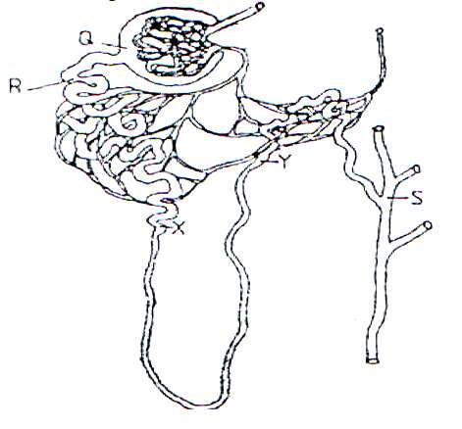

1. Name the fluid in the part labeled Q (1mk)

***Glomerular filtrate***

1. Identify the process responsible for the formation of the fluid named in (a) above. (1 mk)

***Ultra-filtration/pressure filtration;***

1. Which two hormones exert their effect in the Nephron?

***Ant diuretic hormone/vasopressin; Aldosterone;***

22. (a) Osmosis

(b) The amount of sucrose solution increase; the sucrose solution has higher osmotic pressure hence

passes into the potato cavity.

(c) There would be no movement of water; because the photoplasm is killed by boiling, hence the semi-

permeable membrane.

23. (a) Transport, distribution of heat in the body

(b) M-smooth muscle fiber

N-skeletal muscle fiber

(c) -M