**Name** ……………………………………………………………………………. **Class** …..

121/2

**MATHEMATICS**

**FORM 3**

**Paper 2**

2½ Hours

**Instructions to candidates**

1. Write your name, admission number and class in the spaces provided above.

2. The paper contains two sections: **Section I** and **Section II**.Answer **all** the questions in **Section I** and **ANY FIVE** questions from **Section II**.

3. All working and answers must be written on the question paper in the spaces provided below each question.

4. Marks may be awarded for correct working even if the answer is wrong.

5. Negligent and slovenly work will be penalized.

6. Non-programmable silent electronic calculators and mathematical tables are allowed for use.

**For Examiner’s use only Section I**

|  |  |  |  |  |  |  |  |  |  |  |  |  |  |  |  |  |
| --- | --- | --- | --- | --- | --- | --- | --- | --- | --- | --- | --- | --- | --- | --- | --- | --- |
| 1 | 2 | 3 | 4 | 5 | 6 | 7 | 8 | 9 | 10 | 11 | 12 | 13 | 14 | 15 | 16 | Total |
|  |  |  |  |  |  |  |  |  |  |  |  |  |  |  |  |  |

|  |  |  |  |  |  |  |  |  |  |  |
| --- | --- | --- | --- | --- | --- | --- | --- | --- | --- | --- |
| 17 | 18 | 19 | 20 | 21 | 22 | 23 | 24 | Total |  |  |
|  |  |  |  |  |  |  |  |  | Grand Total % |

This booklet contains 16 printed pages. Please confirm that all the pages exist and are properly printed before starting the exam.

**Section I (50 marks)**

**Answer all the questions in this section**

**1.** Use logarithms to evaluate correct to 4 significant figures

 **(4marks)**

**2.** A blend of juice is made from pineapple and passion. The cost of two litres of pineapple is Kshs 120 and three litres of passion is Kshs 270. In what ratio should the juices be mixed such that by selling the mixture at Kshs 84 per lime a profit of 20% is realized? **(3 marks)**

**3**. A ball allowed to drop from a height of 16m on to a floor rebounds to ¾ of its previous height. Find the total heights the ball will have rose when it hits the ground for the tenth time correct to four significant figures 1. **(2 marks)**

**4.** Solve the equation

. **(3 marks)**

**5.** Use completing the square method to solve for in the equation:.

**(3 marks)**

**6.** A shamba is in the shape of a parallelogram with the lengths of the adjacent sides being 12cm and 15cm.If the area of the parallelogram is 72cm2, find the angle between these two sides. **(3 marks)**

**7.** A quantity y varies partly as x2 and partly as x. When y = 6, x = 1 when y = 30, x = 3. Find y when x = - 3. **(3 marks)**

**8.** Two taps A and B together, can fill a water tank in 6 minutes. Tap A alone takes 5 minutes longer to fill the tank than tap B alone. How many minutes does it take tap B alone to fill the tank? **(3 marks)**

**9.** Hisabati originally worked out the mean mark of her forty pupils to be forty one. After confirmation of the marks with her pupils, she added some marks to Tim, Chob and Chel in the ratio 5:2:3 respectively. If the new mean mark for the class increased by 1.5, find how many marks Chel was added than Chob. **(3 marks)**

**10. (a)** Write down the first five terms of the expansion of . **(2 marks)**

**b)** Using the first three terms of the expansion. Find the values of  to 4 decimal places. **(2marks)**

**11.** A school bus was valued at shs 6,000,000 in January 2010. It depreciated by 12.5% of its value at the beginning of the year. Find the value of the bus in January 2015, giving your answer correct to 4 significant figures. **(3 marks)**

**12.** The shadow of a vertical pole is observed on level ground to be 20m long when the angle of elevation of the sun is 30°. Calculate the reduction in the length of the shadow of the pole when the angle of elevation the sun becomes 80°. **(3 marks)**

**13.** A rectangle measures 8.6 cm and 4.8 cm. Find the limits within which the area of the rectangle lies hence find the percentage error in the area. **(3 marks)**

**14.** Solve the equation: .  **(3 marks)**

**15.** The points with coordinates (5, 5) and (-3, 1) are the ends of the diameter of a circle centre A.

Determine:

**(a)** The coordinates of A. **(1mark)**

**(b)** The equation of the circle, expressing it in form x2 + y2 + ax + by + c = 0 Where a, b, and c are constants. **(3 marks)**

**16.** Make the subject of the formula:. **(3 marks)**

**SECTION B: (50 MARKS)**

**Answer any FIVE questions from this section**

**17.** The table below shows income tax rates for the year 2014.

|  |  |
| --- | --- |
| Income in Kenya pounds per month | Rate in Kshs per pound |
| 1 – 484 | 2 |
| 485 – 940 | 3 |
| 941 – 1396 | 4 |
| 1397 – 1852 | 5 |
| Over 1852 | 6 |

In the year of income 2014, the tax on Bushuru’s monthly taxable income was Kshs 10,880.50. Bushuru was entitled to a tax relief of Kshs 1,156.

Find

**i)** Bushuru’s gross monthly tax. **(2marks)**

**ii)** Bushuru’s taxable income per month in shillings. **(6marks)**

**b)** Apart from basic salary, Bushuru earned a house allowance of Kshs 12,000 a medical allowance of Kshs 3,060 and a hardship allowance of Kshs 4,635. Find his basic salary per month. **(2marks)**

**18.** A number is selected at random from 2, 3, 5, 7, 9, and 11 and paired with another number selected from 4, 6, 8, 10, 12, and 14.

**(a)** Construct a table showing how the numbers are paired. **(2 marks)**

**(b)** Find the probability that the sum of the selected numbers is even. **(2 marks)**

**(c)** Find the probability that the sum is odd and prime. **(3 marks)**

**(d)** Find the probability that the sum is greater than the greatest number that can be selected. **(3 marks)**

**19.** Two variables A and B are believed to be related by a law of the form A=mnB + 1.1 where m and n are constants. The table below shows corresponding values of A and B as obtained from an experiment.

|  |  |  |  |  |  |  |
| --- | --- | --- | --- | --- | --- | --- |
| A | 1.79 | 2.27 | 2.48 | 2.96 | 3.21 | 3.79 |
| B | 1.0 | 3.8 | 5.4 | 7.0 | 8.6 | 9.5 |

By drawing a suitable straight line graph estimate the values of m and n. **(10 marks)**

**20.** Matrix **P** is given by.

**(a)** Find **P**-1 **(2marks)**

**(b)** Two traders Mwanzo and Mwisho purchased beans at Kshs x per bag and maize at Kshs y per bag. Mwanzo purchased 8 bags of beans and 14 bags of maize for Kshs 47,600. Mwisho purchased 10 bags of beans and 16 bags of maize for sh. 57,400.

**(i)** Form a matrix equation to represent the information above. **(2marks)**

**(ii)** Use the matrix **P**-1 to find the prices of one bag of each item **(3marks)**

**(c)** The price of bean later went up by 5% and that of maize remained constant. Mwanzo bought the same quantity of beans but spent the same total amount of money as before on the two items. State the new ratio of beans to maize. **(3marks)**

**21.** The figure below represents a quadrilateral piece of land ABCD divided into three triangular plots. The lengths **BE** and **CD** are l00m and 80m respectively. Angle <ABE = 300<ACE = 450 and <ACD =1000

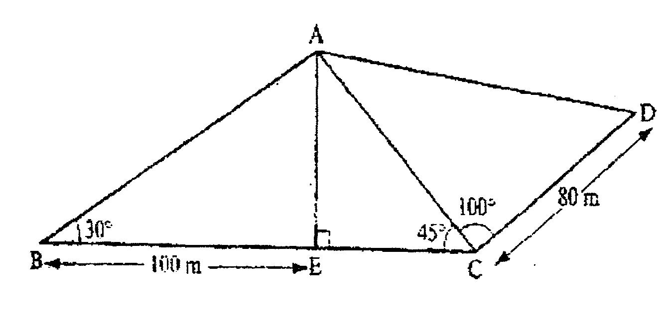

Find to four significant figures:

**(a)** The length of AE **(3marks)**

**(b)** The length of AD **(3marks)**

**(c)** The perimeter of the piece of land  **(4marks)**

**22.** In the triangle OAB below, **OA**= **a**, **OB**= **b**and **OC**= **OA**. M divides OB in the ratio 3:2   
 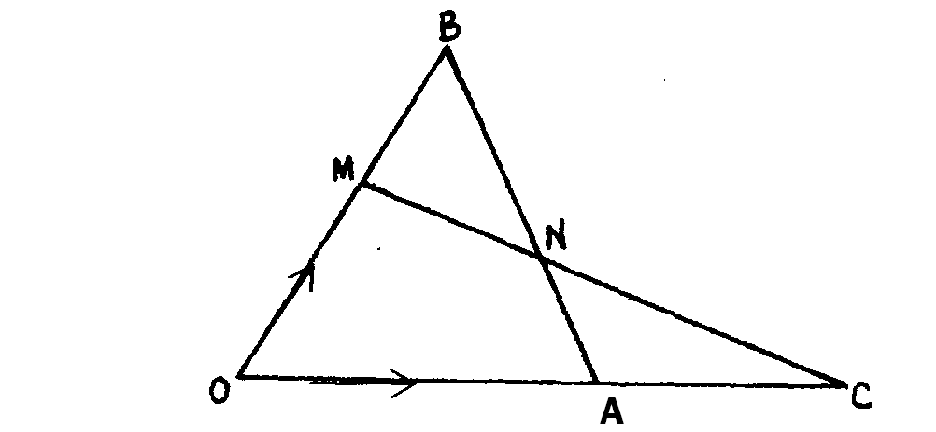

**a)** Express in terms of **a** and **b** only, the vector

**i)**  **(1 mark)**

**ii)**  **(1 mark)**

**b)** Given that **MN**=h**MC**and **BN**= k**BA**, express vector **MN** in two different ways and hence, find the value of h and k. **(6 marks)**

**c)** Show that the points M, N and C are collinear. **(2 marks)**

**23.(a)** The fifth term of an arithmetic progression is 11 and the twenty fifth term is 51. Find the first term and common difference of the progression. **(3 marks)**

**b)** The second and fifth terms of a geometric progression are 16 and 2 respectively. Determine the common ratio and the first term. **(3marks)**

**c)** Find the sum of the following GP**. (4 marks)**

2 + 10 + 50 ……………………….1250

**24.** The figure below shows two intersecting circles of centres C and D radii 16cm and 20cm respectively. The two circles subtend angles at their centres respectively and intersect at P and Q as shown.

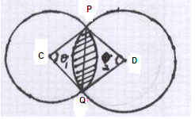

**a)** Given that the area of triangle PCQ is 80.14cm2, calculate the size of

**i)** The angle marked.  **(2marks)**

**ii)** The angle marked.  **(3marks)**

**b)** Calculate the area of the shaded region.  **(5marks)**

**MARKING SCHEME P2**

|  |  |  |  |  |  |  |  |
| --- | --- | --- | --- | --- | --- | --- | --- |
| 1. | |  |  | | --- | --- | | number | log | | Sin 54.5  Tan 24.8  Cos 78  2.912 X 100 |  | | M1  M1  M1  A1 | Correct log + -  Multiplying  C.A.O |
|  |  | 4mks |  |
| 2. | 60x + 90y = 70x + 70y  -10χ = -20y  x : y = 2 : 1 | M1  M1  A1 | Allow alternative  or equivalent methods |
|  |  | 3mks |  |
| 3 |  | M1  A1 | ✓subti to formula  Ao for 45.3 |
|  |  | 2mks |  |
| 4. | (y – 2)² =  y² - 4y + 4 = y  y² - 5y + 4 = 0  (y -1)(y – 4) = 0  y = 1 or 4 | M1  M1  A1 | removal of denominator  expansion  both values |
|  |  | 3mks |  |
| 5. |  | M1  M1  A1 |  |
|  |  | 3mks |  |
| 6. |  | M1  M1  A1 |  |
|  |  | 3mks |  |
| 7. | when x = -3  y = 2 (-3)2 + 4 x -3  = 18 – 12= 6 | M1  A1  B1 | 🗸 equations  🗸 both |
|  |  | 3mks |  |
| 8. | Per min both A and B fill of tank  Let tap B take x min to fill the tank alone  per min both A and B fill for tank | M1  M1  A1 | For two expressions equated  For factors or equivalent |
|  |  | 3mks |  |
| 9. | Total ratio 10  Chelo 6x3=18marks  Chob6x2=12marks  6 marks | M1  M1  A1 | √ attempt to find the difference  Total marks added 60  Different ratio between  3 -2=1  1060  M1A1 |
|  |  | 3mks |  |
| 10 |  | M1  B1  M1  A1 |  |
|  |  | 3mks |  |
| 11 | A = 6000000 ( 0.875)5  A = 3,077,453.613  = kshs 3077000 ( 4s.f) | M1  B1  A1 |  |
|  |  | 3mka |  |
| 13. | Max area = 8.65 x 4.85 = 41.9525 cm2  Min area = 8.55 x 4.75 = 40.6125 cm2  Working area = 8.6 x 4.8 = 41.28cm2  Error = ½ (41.9525 – 40.6125) =  Percentage error = | M1  M1  A1 |  |
|  |  | 3mks |  |
| 14. | Log 8(2 + 3x) = log 4 (2x + 6)  16 + 24x = 8x + 24  16x = 8x = ½ | M1  M1  A1 | ✓ combined of logs or an eqn  ✓ dropping of or an eqn |
|  |  | 3mks |  |
| 15 | )    ( x – 1)2 + ( y – 2) 2 = 20  x2 – 2x+ 1 + y2- 4y + 4 = 20  x2 + y2 – 2x - 4y -20=0 | B1  B1  M1  B1 |  |
|  |  | 4mks |  |
| 16 |  | M1  M1  A1 |  |
|  |  | 3mks |  |
| 17. | a) i) Gross tax = 10880.50 + 1156  = 12036.50  ii) 484 x 2 = 968  456 x 3 = 1368  456 x 4 = 1824  456 x 5 = 2280  (x – 1852) 6 x 20  = ksh 55695  b) Basic 55695-(3060 + 4635 + 12000)  ksh 36000 | M1  A1  B1  B1  B1  B1  M1  A1  M1  A1 | X x6 = 5596.5  X = 932.75  (484 + (456 x 3)+932.75)20 |
|  |  | 10mks |  |
| 18. | |  |  |  |  |  |  |  | | --- | --- | --- | --- | --- | --- | --- | |  | 2 | 3 | 5 | 7 | 9 | 11 | | 4 | 4, 2 | 4, 3 | 4, 5 | 4, 7 | 4,9 | 4,11 | | 6 | 6, 2 | 6, 3 | 6, 5 | 6, 7 | 6,9 | 6,11 | | 8 | 8, 2 | 8, 3 | 8, 5 | 8, 7 | 8,9 | 8,11 | | 10 | 10, 2 | 10, 3 | 10, 5 | 10,7 | 10,9 | 10,11 | | 12 | 12, 2 | 12, 3 | 12, 5 | 12,7 | 12,9 | 12,11 | | 14 | 14, 2 | 14, 3 | 14, 5 | 14,7 | 14,9 | 14,11 |   b) P (Sum even) = P (2, 4) or P (2, 6) or P (2, 8)  or P(2, 10) or P(2, 12) or P(2, 14)      P (Sum odd and prime) = P(3, 4) or P(3, 8) or P(3, 10)  (d) P (Sum > 14) = No of favourable outcomes  Total outcomes | B1  B1  M1  A1  M1  M1  A1  M1  M1  A1 | B2 🗸 all correct  B1🗸 for more then ¾  🗸 for list M1M1  R1 – 1 🗸M1M1 for list or  R2 – 2  R3 – 3 |
|  |  | 10mks |  |

|  |  |  |  |  |  |  |  |  |  |  |  |  |  |  |  |  |  |  |  |  |  |  |  |  |
| --- | --- | --- | --- | --- | --- | --- | --- | --- | --- | --- | --- | --- | --- | --- | --- | --- | --- | --- | --- | --- | --- | --- | --- | --- |
| 19. | |  |  |  |  |  |  |  | | --- | --- | --- | --- | --- | --- | --- | | B | 1.0 | 3.8 | 5.4 | 7.0 | 8.6 | 9.5 | | A-1.1 | 0.69 | 1.17 | 1.38 | 1.86 | 2.11 | 2.69 | | Log(A-1.1) | -0.16 | 0.07 | 0.14 | 0.27 | 0.32 | 0.43 |   Log (A-1.1) = log m + Blog n | B1  B2  B1  B1  B1  B1  M1  A1  M1  A1 | All values✓  At least 3✓  ✓linear scale  ✓ plotting  ✓line drawn |
|  |  | 10mks |  |
| 20 | A1          Beans per bag=Ksh,3500  Maize per bag =Ksh.1400        Bean : maize  7 : 14 = 1 : 2 | M1  A1  B2  M1  M1  A1  M1  M1  A1 |  |
|  |  | 10mks |  |
| 21 | (ii) | M1  M1  A1  B1  M1  A1  B1  B1  M1  A1 |  |
|  |  | 10mks |  |
| 22 | a) i) **AB** =**AO** + **OB**  = **b** – **a**  **ii) MC** = **MO** + **OC**  = 3/2 **OA** + **MO**  =3/2**a -** 3/5**b**  b) **MN** = h **MC**  = h(3/2 **a** - 3/5 **b**) = (3/2h **a** - 3/5h **b**)  Also **MN** = **MB** + **BN**  = 2/5**b** + k**BA**  = 2/5**b** + k(**a**-**b**)  = (2/5 – k)**b** + k**a** = 3/2h**a** - 3h**b**  k = 3/2h and (2/5 – k)**b** = -3/5h**b**  k = 3/2 and 2/5 – k = 3/5h  k = 2/3 h = 4/9  (c) **MN** = **MC**  The vectors **MN** and **MC** must be parallel to each other. But they cannot be parallel because the y share a common point M thus points M, N and C are collinear | B1  B1  M1  A1  B1  B1  B1  B1  B1  B1 |  |
|  |  | 10mks |  |
| 23. | d = 2 a = 11 – 8= 3  b) Ar = 16 ...........(i)  Ar4 = 2 ..................(ii)      = ½  a x ½ = 16  a = 32  c) 2 + 10 + 50 ……………….1250  a = 2,  = 5  last term = 9r n-1 = 1250    5 n -1 = 625=54  n=5 | M1  M1  A1  M1  A1  B1  M1  M1  M1  A1 | both equations  attempt to solve the simequ  both values 🗸 |
|  |  | 10mks |  |
| 24 |  | M1  A1  M1  M1  A1  M1  M1  M1  M1  A1 | Area of 1st segment |
|  |  | 10mks |  |