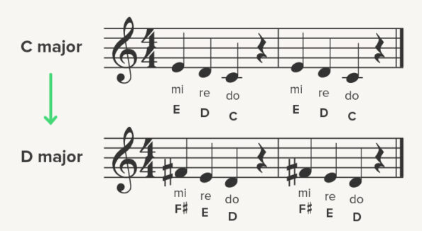


GRADE 10
COMPETENCE BASED CURRICULUM
SENIOR SCHOOL
GRADE GUIDE NOTES
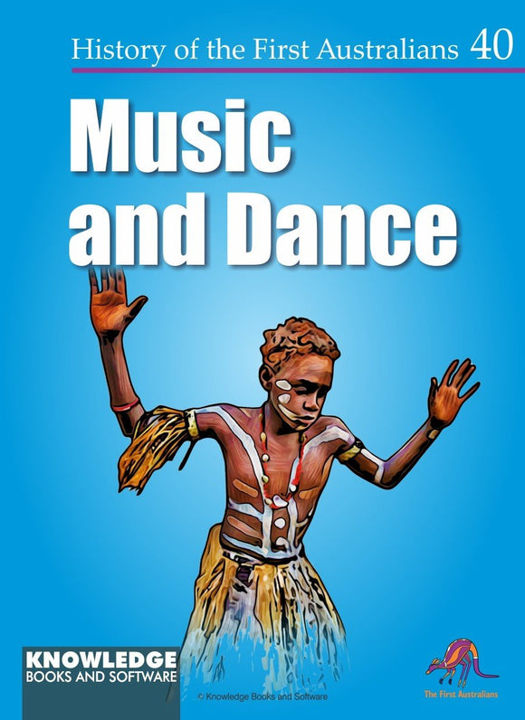
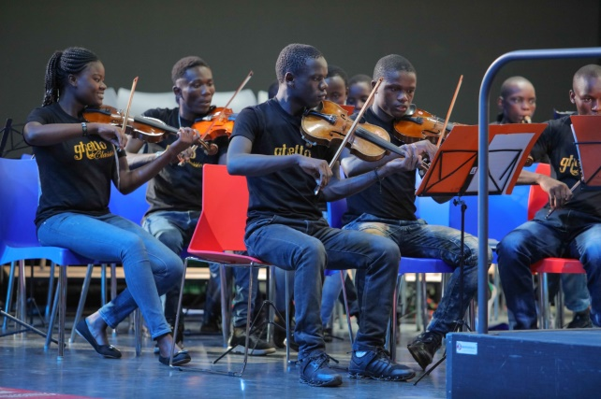

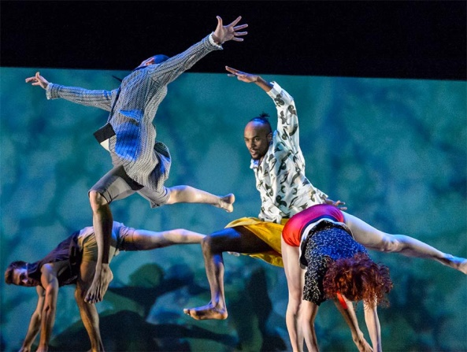
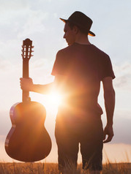
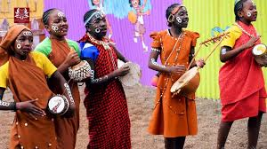
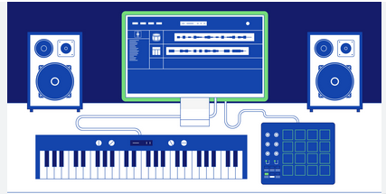
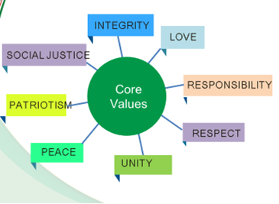

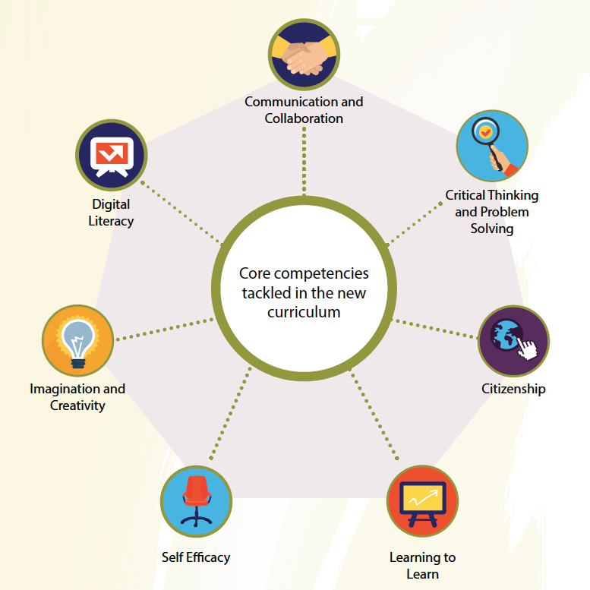

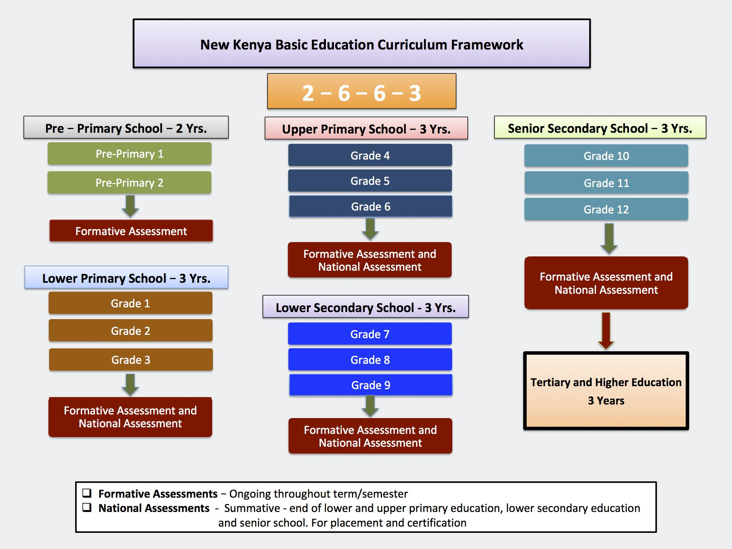

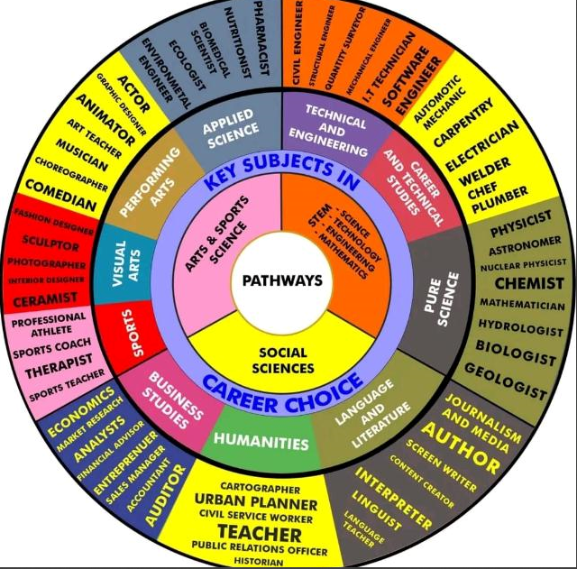

LIST OF LEARNING AREAS AT SENIOR SCHOOL
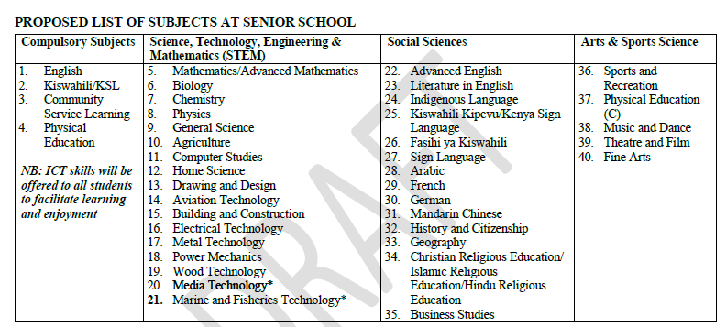

LESSON DISTRIBUTION AT SENIOR SCHOOL
The number of lessons in each of the compulsory learning areas shall be 4; while the optional areas shall be 6 lessons each. A lesson shall be 40 minutes. The "free" lessons shall be used for development of ICT skills, Pastoral Instruction Programme (PPI), projects, collaborative study and further reading.

NATIONAL GOALS OF EDUCATION
Education in Kenya should:
1. Foster nationalism and patriotism and promote national unity.
Kenya’s people belong to different communities, races and religions, but these differences need not divide them. They must be able to live and interact as Kenyans. It is a paramount duty of education to help young people acquire this sense of nationhood by removing conflicts and promoting positive attitudes of mutual respect which enable them to live together in harmony and foster patriotism in order to make a positive contribution to the life of the nation.
2. Promote the social, economic, technological and industrial needs for national development.
Education should prepare the youth of the country to play an effective and productive role in the life of the nation.
a) Social Needs
Education in Kenya must prepare children for changes in attitudes and relationships which are necessary for the smooth progress of a rapidly developing modern economy. There is bound to be a silent social revolution following in the wake of
rapid modernization. Education should assist our youth to adapt to this change.
b) Economic Needs
Education in Kenya should produce citizens with the skills, knowledge, expertise and personal qualities that are required to support a growing economy. Kenya is building up a modern and independent economy which is in need of an adequate and
relevant domestic workforce.
c) Technological and Industrial Needs
Education in Kenya should provide learners with the necessary skills and attitudes for industrial development. Kenya recognizes the rapid industrial and technological changes taking place, especially in the developed world. We can only be
part of this development if our education system is deliberately focused on the knowledge, skills and attitudes that will prepare our young people for these changing global trends.
3. Promote individual development and self-fulfilment
Education should provide opportunities for the fullest development of individual talents and personality. It should help children to develop their potential interests and abilities. A vital aspect of individual development is the building of character.
4. Promote sound moral and religious values.
Education should provide for the development of knowledge, skills and attitudes that will enhance the acquisition of sound moral values and help children to grow up into self-disciplined, self-reliant and integrated citizens.
5. Promote social equality and responsibility.
Education should promote social equality and foster a sense of social responsibility within an education system which provides equal educational opportunities for all. It should give all children varied and challenging opportunities for collective activities and corporate social service irrespective of gender, ability or geographical environment.
6. Promote respect for and development of Kenya’s rich and varied cultures.
Education should instill in the youth of Kenya an understanding of past and present cultures and their valid place in contemporary society. Children should be able to blend the best of traditional values with the changing requirements that must follow rapid development in order to build a stable and modern society.
7. Promote international consciousness and foster positive attitudes towards other nations.
Kenya is part of the international community. It is part of the complicated and interdependent network of peoples and nations.
Education should therefore lead the youth of the country to accept membership of this international community with all the obligations and responsibilities, rights and benefits that this membership entails.

8. Promote positive attitudes towards good health and environmental protection.
Education should inculcate in young people the value of good health in order for them to avoid indulging in activities that will lead to physical or mental ill health. It should foster positive attitudes towards environmental development and conservation. It should lead the youth of Kenya to appreciate the need for a healthy environment.

LEVEL LEARNING OUTCOMES
By the end of Senior School, the learner should be able to:
1. Communicate effectively and utilise information and communication technology across varied contexts.
2. Apply mathematical, logical and critical thinking skills for problem solving.
3. Apply basic research and scientific skills to manipulate the environment and solve problems.
4. Exploit individual talents for leisure, self-fulfilment, career growth, further education and training.
5. Uphold national, moral and religious values and apply them in day to day life.
6. Apply and promote health care strategies in day to day life.
7. Protect, preserve and improve the environment for sustainability.
8. Demonstrate active local and global citizenship for harmonious co-existence.
9. Demonstrate appreciation of diversity in people and cultures.
10. Manage pertinent and contemporary issues responsibly.

THE SENIOR SCHOOL IN THE COMPETENCY BASED CURRICULUM (CBC)
Senior School is the forth level of Basic Education in the Competency Based Curriculum (CBC) that learners shall come to after the Pre-Primary, Primary and Junior School (JS). The essence of Senior School is to offer learners a Pre-University/ Pre- career experience where the learners have an opportunity to choose pathways where they have demonstrated interest and/or potential at the earlier levels. Senior school comprises three years of education for learners in the age bracket of 15 to 18 years and lays the foundation for further education and training at the tertiary level and the world of work. In the CBC vision, learners exiting this level are expected to be engaged, empowered and ethical citizens ready to participate in the socio-economic development of the nation.
At this level, learners shall take SEVEN (07) learning areas (LAs) as recommended by the Presidential Working Party on Educational Reforms (PWPER). These shall comprise Four Compulsory learning areas, and Three learning areas opted for by
the learner according to their choses Pathway. While English and Kiswahili are indicated as Compulsory, the learners who opt for these learning areas as their subjects of specialization shall go through a differentiated curriculum in terms of scope, experiences and assessment. Such learners shall; therefore, take Advanced English or Kiswahili Kipevu with additional two lessons. It is recommended that AT LEAST TWO learning areas should be from chosen Pathway. In exceptional cases, some learners may opt for ONE learning area from the chosen Pathway and a maximum of TWO learning areas from any of the three pathways; depending
on the learner’s career projections and with guidance by the principals at Senior School.

PROPOSED LIST OF SUBJECTS AT SENIOR SCHOOL
LESSON DISTRIBUTION AT SENIOR SCHOOL
The number of lessons in each of the compulsory learning areas shall be 4; while the optional areas shall be 6 lessons each. A lesson shall be 40 minutes. The "free" lessons shall be used for development of ICT skills, Pastoral Instruction Programme (PPI), projects, collaborative study and further reading.
ESSENCE STATEMENT
Music and Dance are unique arts that are significant for the holistic development of humankind. These arts are useful for the growth of the cognitive, affective and psycho-motor domains of learning in an individual. They influence one’s feelings, thoughts, and actions, which lead to the understanding of self, their immediate environment and the entire world.
Music and Dance as a learning area at Senior Secondary School, will build on the knowledge, skills, attitudes and values that learners acquired at lower levels as they explore new concepts and experiences. This learning area will provide the learner with opportunities to advance three key competencies: creating, performing, and appreciating Music and Dance works through
participatory and experiential approaches. The learner will be exposed to Music and Dance from diverse Kenyan and global cultures, contributing to the development of their affection for traditions, artistic sensibility, personal autonomy, life skills and physical well-being.
The study of Music and Dance will enable the learner to pursue further studies and careers in education, composition, choreography, event organization, directing, arts management, music production and technology, music journalism, sound engineer and music therapy among others. This makes Music and Dance a key contributor to the creative economy.

SUBJECT GENERAL LEARNING OUTCOMES
By the end of senior secondary school, the learner should be able to:
1. Apply relevant knowledge, skills, values and attitudes, to create, perform and analyse Music and dance.
2. Appreciate diverse local and global cultures through listening, analysis and performance of Music and Dance.
3. Perform Music and Dance from various cultures for self- and cultural expression, and preservation.
4. Use available technologies to enhance learning and develop creativity in Music and Dance.
5. Apply research and innovation skills in the sustainable utilization of locally available resources for Music and Dance creation, performance and appreciation.
6. Relate Music and Dance to other arts and non-art disciplines to make meaningful connections.
7. Promote cultural, national, moral and religious values through Music and Dance.
8. Develop responsive and responsible global citizenship through involvement in Music and Dance activities from diverse cultures.
9. Utilise individual potential in Music and Dance for leisure, self-fulfilment, further education and training, and career growth.
10. Address pertinent and contemporary issues in society through Music and Dance activities.

SUMMARY OF STRANDS AND SUB STRANDS
1.0 FOUNDATIONS OF MUSIC AND DANCE
1.1 Rhythm
1.2 Melody in Major Keys
1.3 Transposition
1.4 Setting Text to Music
1.5 Two-Part Harmony
1.6 Music Notation Software
1.7 Dance Production
2.0 Performing and Displaying
2.1 Kenyan Folk Songs
2.2 Western Style Solo Songs
2.3 Kenyan Indigenous Musical Instruments
2.4 Western Musical Instruments (Solo Performer)
2.5 Contemporary Dances-Kenyan
3.0 Critical Appreciation 3.1 Kenyan Folk Songs
3.2 Classical Music ( Medieval and Renaissance)
3.3 Music and Dance in Socio-Cultural Context

1.0 FOUNDATIONS OF MUSIC AND DANCE
1.1 Rhythm
This section will explore the exciting world of rhythm, focusing on:
- Semiquavers: These speedy notes are like tiny bursts of sound.
- Triplets: These groups of three notes add a unique swing to the music.
- Simple Time Signatures: We'll work with common time signatures like 2/4, 3/4, and 4/4.

Understanding Semiquavers
A semiquaver is a note that represents one-sixteenth of a whole note. It's like a super-fast quaver!
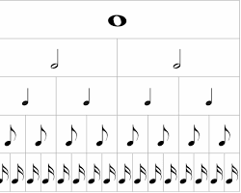
- Notation: It's written as a filled-in oval with two flags.
- Sound: Imagine a very quick, short sound.

Exploring Triplets
A triplet is a group of three notes played in the time of two of the same kind of note.
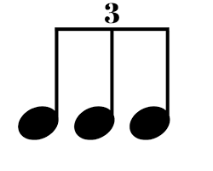
- Notation: Three notes are grouped together with a "3" written above or below them.
- Sound: It creates a distinctive rhythmic pattern, like a quick "one-two-three" sound.

Simple Time Signatures
Simple time signatures are those where each beat can be divided into two equal parts.
- 2/4 Time: Two beats per measure, each a quarter note.
- 3/4 Time: Three beats per measure, each a quarter note.
- 4/4 Time: Four beats per measure, each a quarter note.
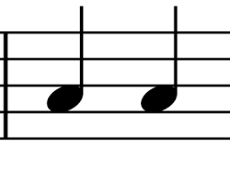
1.2 Melody in Major Keys
This sub-strand focuses on expanding your understanding of melody, particularly within major keys. You'll learn about melodic devices, constructing major scales, and adding articulation to your melodies.
Key Concepts:
- Melodic Devices:
  - Scalic Motion: Moving up or down a scale step by step.
    - Example: C-D-E-F-G (ascending), G-F-E-D-C (descending).
  - Arpeggios: Playing the notes of a chord in succession.
    - Example: C-E-G (C major arpeggio).
- Major Scales:
  - You'll be constructing major scales of D, A, B flat, and E flat on both the treble and bass clefs.
  - Remember the pattern of whole and half steps in a major scale: Whole-Whole-Half-Whole-Whole-Whole-Half.
- Structure:
  - Understanding question and answer phrases in melodies.
    - A question phrase creates a sense of anticipation, while an answer phrase provides resolution.
- Articulation Marks:
  - Slur: A curved line connecting two or more notes, indicating they should be played smoothly.
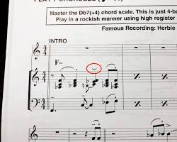
slur articulation mark
  - Staccato: A dot placed above or below a note, indicating it should be played short and detached.
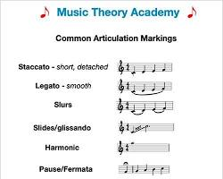
Staccato articulation mark
1.3 Transposition
This sub-strand focuses on the important musical skill of transposition, which involves changing the key or register of a piece of music.
Key Concepts:
- Intervals:
  - The "distance" between two notes.
  - Melodic Intervals: Notes played one after the other.
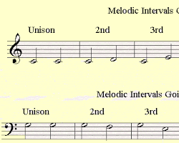
  - Harmonic Intervals: Notes played at the same time.
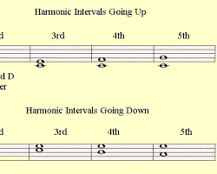
  - Interval Quality:
    - Major, minor, perfect.
  - Interval Size:
    - 2nd, 3rd, 4th, 5th, and 8ve (octave).
- Transposition:
  - Changing the pitch of a piece of music.
  - Types of Transposition:
    - Interval Transposition: Moving a melody up or down by a specific interval.
      - Example: Transposing a melody up a 2nd.
    - Clef Transposition: Moving music from treble to bass clef (or vice versa).
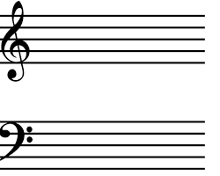
    - Key Transposition: Changing the overall key of a piece.
      - Example: Transposing a melody from C major to G major.
1.4 Setting Text to Music
This sub-strand is all about the beautiful art of combining words and music, with a focus on Kiswahili.
Key Concepts:
- Process of Setting Text to Music:
  - Syllabic Division:
    - Breaking words into syllables to match musical notes.
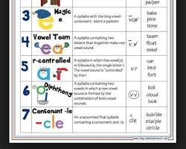
  - Accents (Strong and Weak):
    - Emphasizing certain syllables for rhythmic effect.
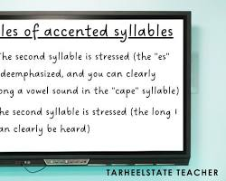
  - Natural Speech Inflection/Intonation of Words:
    - Matching the rise and fall of spoken language with musical pitch.
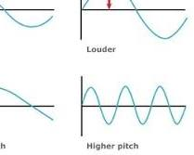
  - Rhythm:
    - Choosing rhythmic patterns that suit the text.
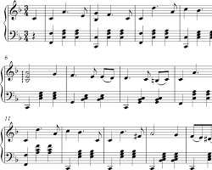
  - Time Signature:
    - Selecting a time signature that complements the rhythm.
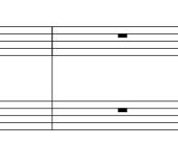
  - Cadential Points:
    - Identifying points of rest or resolution in the music.
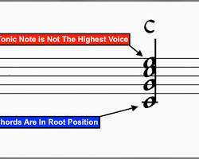
  - Pitch:
    - Assigning pitches to syllables to convey meaning and emotion.
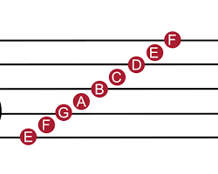
- Downbeat and Upbeat (Anacrusis):

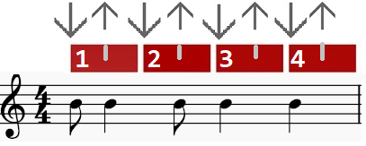
1.5 Two-Part Harmony
This sub-strand introduces the fundamentals of creating harmony with two distinct musical lines.
Key Concepts:
- Two-Part Harmony Guidelines:
  - Beginning:
    - Often starts with unison (same note), perfect 5ths, or octaves.
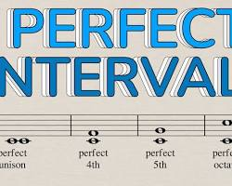
Unison, Perfect 5th, and Octave Intervals
  - Motion:
    - Stepwise motion (moving by scale steps), leaps (larger intervals), and note-to-note movement.
  - Intervals:
    - Using consonant intervals: major 3rd, minor 3rd, perfect 4th, perfect 5th, major 6th, minor 6th, and octave.
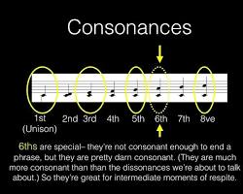
Consonant intervals on a music staff
  - Ending:
    - Typically ends with unison or octaves for resolution.
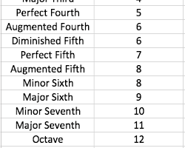
Unison and octave intervals at the end of a musical phrase
Practical Application:
- Interval Identification: Practice identifying consonant intervals by ear.
- Harmonization Exercises: Harmonize simple melodies using the guidelines.
- Performance Practice: Perform your harmonized melodies.
- Composition Projects: Create original two-part harmonic pieces.
1.6 Music Notation Software
This sub-strand focuses on using technology to write and manipulate music.
Key Concepts:
- Navigate Music Notation Software:
  - Opening, keying in notes, playing back, saving, and editing music.
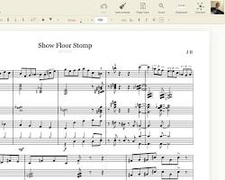
Music notation software interface
- Transcribe Music:
  - Writing scales, melodies, intervals, and two-part harmony using the software.
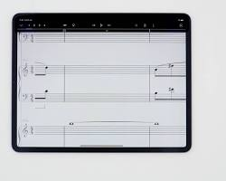
Musical staff with notes being entered into music notation software
- Saving:
  - Saving music files in MIDI, print (PDF), and audio formats.
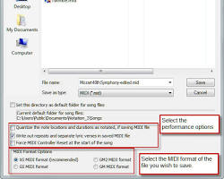
Save dialog box in a music notation software showing different file format options
Suggested Learning Experiences:
- Watch demos of various music notation software online: Explore software like MuseScore, Sibelius First, Noteworthy, Encore, Finale Notepad, Notion, and Maestro.
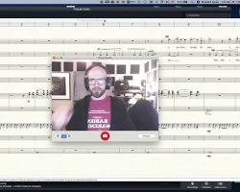
Computer screen showing a music notation software demo on you tube
- Discuss various notation software and mobile apps: Share experiences and knowledge.
- Navigate selected music notation software to view music notation tools: Learn the interface.
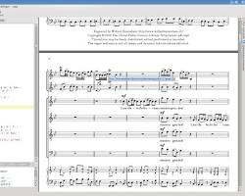
Music notation tool bar in a music notation software
- Use music notation software to key in music: Enter notes and rhythms.
- Edit keyed-in music: Correct and refine your work.
- Save and convert music to MIDI, print, and audio formats: Export your music in different ways.
- Share, play back, and appraise music: Listen to and critique your own and others' work.
Practical Application:
- Software Exploration: Experiment with different music notation software.
- Transcription Exercises: Transcribe musical examples using the software.
- Composition Projects: Create original music using the software.
- File Format Comparison: Listen to the same music in MIDI and audio formats.
1.7 Dance Production
This sub-strand focuses on the various elements that go into creating a compelling dance performance.
Key Concepts:
- Elements of Dance:
  - Body: The physical form of the dancer.
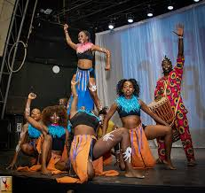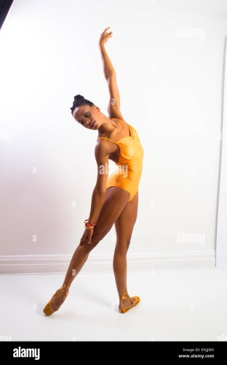
  - Action: The movements performed by the dancer.
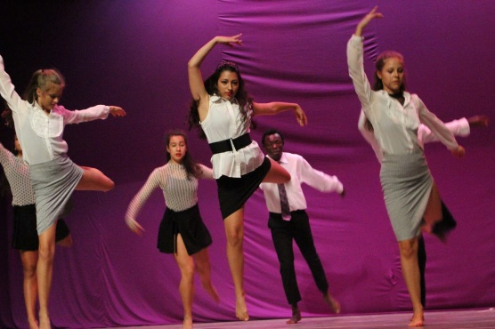
  - Space: The area in which the dancer moves.
  - Time: The rhythm and speed of the movements.
  - Energy: The force and quality of the movements.
- Functions of Costumes, Props, and Set Design:
  - Enhancing the visual and thematic aspects of the dance.
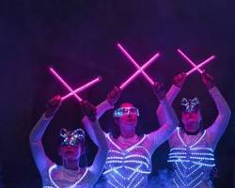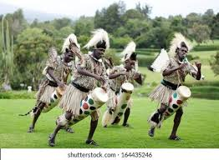
Dancers wearing thematic costumes and using props
- Design of Costumes:
  - Creating costumes that reflect the dance's theme.
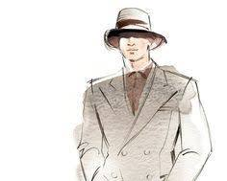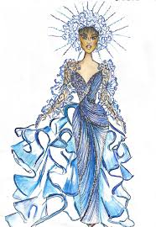
Costume design sketch
- Multimedia:
  - Using technology to enhance the performance.
- Choice of Music, Lighting, and Sound Effects:
  - Selecting elements that complement the dance.
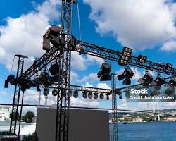
Stage lighting and sound equipment .
Suggested Learning Experiences:
- Watch a variety of dances and discuss the elements of dance: Analyze different dance styles.
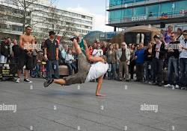
People watching a dance performance
- Source or use available materials to improvise props: Create props using recycled or everyday items.
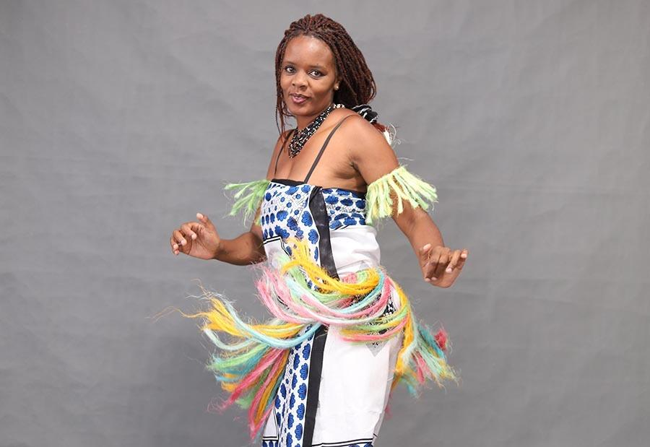
Improvised props used in a dance
- Choose a dance theme based on a PCI and design an appropriate costume: Create costumes that reflect relevant themes.

Person designing a costume
- Watch online or live demonstrations on use of music, lighting, and sound effects: Learn about technical aspects of dance production.
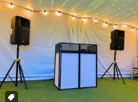
Lighting and sound equipment
- Apply multimedia effects in production of a dance performance during a school event: Incorporate technology into a live performance.
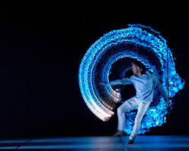
Dance performance with multimedia effects
Practical Application:
- Dance Analysis: Analyze dance performances to identify the elements of dance.
- Prop and Costume Design: Create props and costumes for a hypothetical dance.
- Multimedia Integration: Plan how to incorporate multimedia effects into a dance performance.
- Choreography Exercises: Create short dance sequences.
- Performance Projects: Produce and perform a dance piece.

2.0 PERFORMING
2.1 Kenyan Folk Songs
This sub-strand focuses on the performance and appreciation of Kenyan folk songs.
Key Concepts:
- Characteristics of Kenyan Folk Songs:
  - Traditional melodies and rhythms.
  - Storytelling and cultural significance.
  - Use of indigenous languages.
  - Often associated with specific occasions or communities.
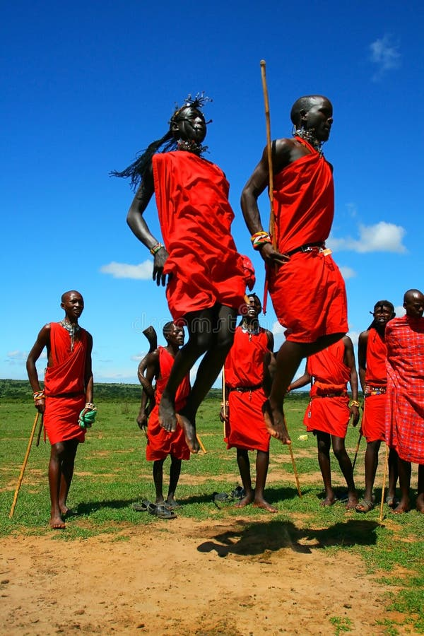
People singing and dancing to a folk song in traditional attire
- Folksongs:
  - Solo performances.
  - Group performances.
- Choice:
  - Gender-specific songs.
  - Age-specific songs.
  - Occasion-specific songs.
  - Use of appropriate costumes, props, and artifacts.
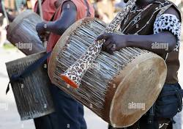
Traditional Kenyan costumes and musical instruments
- Performance Aspects:
  - Singing (tone and diction).
  - Idiom (cultural context).
  - Synchrony (togetherness).
  - Transitions (smooth changes).
  - Instrumentation (use of instruments).
  - Projection and diction (clarity).
  - Expressiveness (emotion).
  - Etiquette (performance behavior).
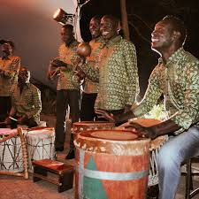
People performing a folk song with instruments
Suggested Learning Experiences:
- Listen to or watch performances of Kenyan folk songs and discuss the characteristics:

People watching a folk song performance
- Source from virtual or physical spaces to select Kenyan folk songs:
- Source for and select instruments, costumes, props, and artifacts, make-up and décor:
- Take up different roles in the performance (soloist, instrumentalists, group singers):
- Carry out rehearsals observing rehearsal etiquette and safety procedures:
- Perform a Kenyan group folk song before an audience, applying the appropriate performance aspects:
- Record and share the performances with peers for feedback: Practical Application:
- Listening to and analyzing recorded folk songs.
- Researching and selecting folk songs from different Kenyan communities.
- Practicing and performing folk songs in solo and group settings.
- Using appropriate costumes, props, and instruments.
- Recording and sharing performances for feedback.
2.2 Western Style Solo Songs
This sub-strand focuses on the performance of Western-style solo vocal music.
Key Concepts:
- Performance Style:
  - Understanding the specific style of different genres (lieder, arias, musical theatre songs).
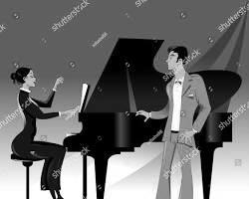
Singer performing an aria from an opera
- Accuracy:
  - Pitch accuracy (singing the correct notes).
  - Rhythmic accuracy (singing the correct rhythms).
- Performance Directions:
  - Tempo (speed of the music).
  - Dynamics (volume of the music).
  - Repeats and reiterations (following musical instructions).
Performance Techniques:
  - Phrasing (shaping musical lines).
  - Posture (body position).
  - Diction (clarity of words).
  - Poise (stage presence).
  - Musicianship (musical understanding).
Suggested Learning Experiences:
- Listen to or watch live or recorded performances of lieder, arias from operas and oratorios, and solo songs from musicals for familiarization:
- Discuss the performance practice of Western solo songs such as lieder, arias, folk songs:
- Review videos of Western solo songs to identify their styles of singing:
- Execute various vocal styles applied in singing Western solo songs:
- Select acknowledging the source suitable Western solo songs for performance:
- Perform selected Western solo songs before a given audience, while observing the performance techniques:

Person performing a solo song on stage
- Use digital devices to record their performances of Western solo songs and upload them to their digital portfolios:
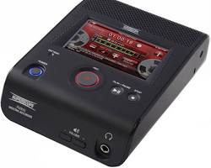
Digital audio recorder
- Evaluate performances by self and others and respectfully give feedback:
Suggested Key Inquiry Questions:
- 1. How should one prepare to perform a Western solo song?
- 2. Why are vocal techniques important in Western solo songs?
Practical Application:
- Listening to and analyzing recordings of Western solo songs.
- Practicing vocal techniques such as phrasing, diction, and posture.
- Learning and performing songs in different Western solo styles.
- Recording and evaluating performances.
- Giving and receiving constructive feedback.
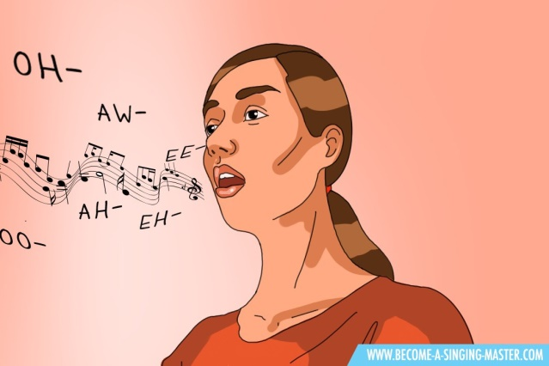
Someone practicing vocal exercises
2.3 Kenyan Indigenous Musical Instrument (Solo Performance)
This sub-strand focuses on the solo performance of Kenyan indigenous musical instruments.
Key Concepts:
- Indigenous Musical Instruments:
  - Fiddle (Orutu).
  - Lyre (Nyatiti).
  - Harp (Obokano).
  - Flute (Engorare).
  - Drum or drum set (Engalabi, Isukuti).
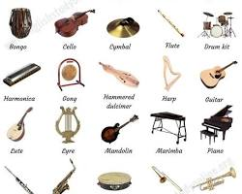
Suggested Learning Experiences:
- Listen or watch performances involving Kenyan indigenous musical instruments to determine how sound is produced:
- Familiarise with a selected Kenyan indigenous musical instrument to identify its parts and handling:
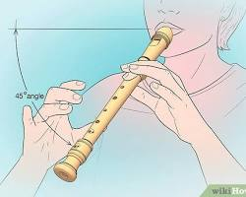
Someone holding a specific instrument and pointing out its parts
- Search responsibly for videos and watch or interact with resource persons to learn the techniques of tuning, playing, and maintaining the instrument:
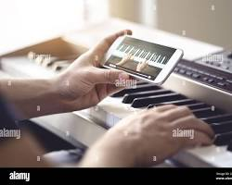
Person watching an instructional video on how to play an instrument
- Practice the techniques of tuning of the instrument:
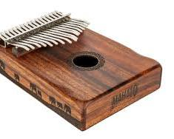
Someone tuning an indigenous musical instrument
- Rehearse playing a selected Kenyan indigenous musical instrument to master the playing techniques:
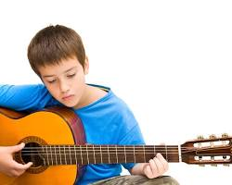
Someone practicing playing an instrument
- Play tunes or rhythmic patterns from the cultural idiom of the chosen instrument using the appropriate playing techniques before an audience:
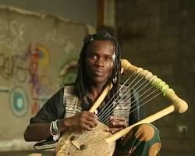
Someone playing a solo performance of an indigenous instrument
- Record and share music with parents, guardians, and fellow learners for feedback and upload to a digital portfolio:
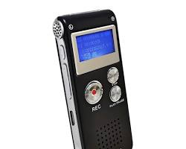
Recording device
Suggested Key Inquiry Questions:
- 1. How can proficiency in solo instrumental playing be developed?
- 2. What features of a solo instrument mark its cultural identity?
Practical Application:
- Listening to and analyzing recordings of indigenous instrumental music.
- Learning the parts and handling of a selected indigenous instrument.
- Practicing tuning and playing techniques.
- Performing solo pieces from the cultural idiom of the chosen instrument.
- Recording and sharing performances for feedback.
- Researching the cultural significance of the instrument.
2.4 Western Musical Instruments (Solo Performer)
This sub-strand focuses on the solo performance of Western musical instruments.
Key Concepts:
- Western Instruments:
  - Strings (violin, guitar, cello).
  - Brass (trumpet, trombone, French horn).
  - Woodwind (flute, clarinet, saxophone).
  - Percussion (drums, xylophone, timpani).
  - Piano/organ.
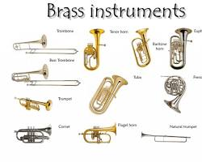
each instrument category with examples
- Playing Techniques:
  - Tonguing (brass and woodwind).
  - Bowing (strings).
  - Picking (guitar).
  - Strumming (guitar).
  - Plucking (harp, guitar).
  - Striking (percussion, piano).
Suggested Learning Experiences:
- Observe pictures or real instruments and identify various parts and their role in the production of sound:
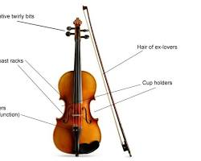
Diagram of a musical instrument with its parts labeled
- Tune or explain the tuning of a selected Western solo instrument:
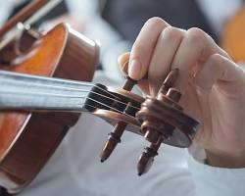
Someone tuning a musical instrument
- Prepare a rehearsal schedule for practicing techniques earlier learnt on the selected Western solo instrument:
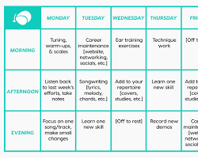
Practice schedule
- Practice playing techniques that are specific to the selected Western solo instrument:
- Play a variety of solo pieces of music on a selected solo instrument during a school function:
Practical Application:
- Observing and identifying the parts of Western instruments.
- Learning and practicing tuning techniques.
- Developing a practice schedule and sticking to it.
- Practicing specific playing techniques for the chosen instrument.
- Performing solo pieces for an audience.
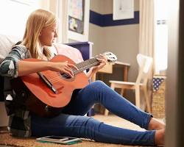
Someone practicing a musical instrument
2.5 Contemporary Dance from Kenya
This sub-strand focuses on creating and performing contemporary dance routines based on Kenyan popular music.
Key Concepts:
- Contemporary Dance Features:
  - Storyline: Using dance to tell a narrative.
  - Use of body in space: Exploring different spatial relationships.
  - Improvisation: Spontaneous movement.
  - Styles from other genres: Blending various dance styles.
  - Music, costume, and décor: Using these elements to enhance the performance.
- Basic Performing Skills:
  - Posture: Correct body alignment.
  - Alignment: Proper body positioning.
  - Balance: Maintaining stability.
  - Coordination: Smooth movement integration.
  - Control: Precise movement execution.
- Performance Techniques:
  - Controlled leg work: Precise leg movements.
  - Floor work: Movements performed on the ground.
  - Improvisation: Spontaneous creation of movement.
  - Fall and recovery: Controlled falls and rises.
  - Movement and release: Contrasting tension and relaxation.
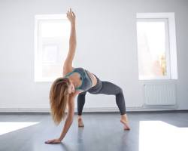
Dancer doing floor work
- Dance Choreography based on Kenyan popular music:
  - Rhumba, benga, genge, hip-hop, Kenyan rock, genge tone, taarab, rap, and kapuka.
Suggested Learning Experiences:
- ● Watch real or virtual contemporary dance performances and discuss their features:
- ● Brainstorm an idea on a PCI from the community for a dance story:
- ● Create milestones for the contemporary dance story:
- ● Demonstrate basic performance skills in a dance routine:
- ● Select suitable contemporary dance techniques and styles from genres of Kenyan popular music for the routine:
- ● Block dance movements and patterns for effective use of time, space, action, and energy:
- ● Select and use appropriate music for the dance routine:
- ● Select and use appropriate costumes, props, and make-up for the routine:
Practical Application:
- Analyzing contemporary dance performances.
- Creating dance routines based on Kenyan popular music.
- Practicing basic performance skills and techniques.
- Choreographing and performing a contemporary dance piece.
3.0 Critical Appreciation
3.1 Kenyan Folk Songs
This sub-strand focuses on the critical analysis and appreciation of Kenyan folk songs.
Key Concepts:
- Performance Media:
  - Vocal (singing only).
  - Vocal and instrumental (singing with instruments).
- Performance Styles:
  - Solo (one performer).
  - Call-response (leader and group).
  - Choral (group singing).
  - Overlapping (different parts entering at different times).
  - Polyrhythms (multiple rhythms at once).
  - Imitation (repeating musical phrases).
- Elements of Music:
  - Structure (form of the song).
  - Rhythm (pattern of sounds).
  - Melodies/tunes (sequence of notes).
  - Pitching (highness or lowness of notes).
  - Tempo (speed of the music).
  - Tone colour (quality of sound).
  - Texture (layers of sound).
  - Harmony (combination of notes).
  - Intensity (loudness or softness).
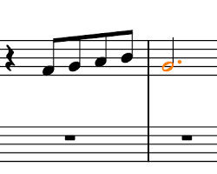
Musical staff showing rhythm and melody
- Expressive Elements:
  - Vocal ornaments (embellishments).
  - Singing styles (different vocal techniques).
  - Gestures (body movements).
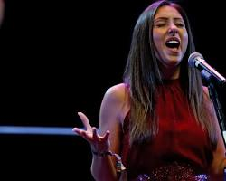
Singer using expressive hand gestures
Suggested Learning Experiences:
- • Listen to or watch live or recorded Kenyan traditional folk music with controlled volume and classify performance media:
- • Discuss the role of performance media and the various players in Kenyan folksongs:
- • Identify the styles of Kenyan folksongs performance:
- • Discuss how the elements of music feature in various Kenyan folksongs performances:
- • Listen to or watch performances of Kenyan folksongs and interpret the expressive devices used:
- • Listen to or watch performances of Kenyan folksongs and discuss message(s):
Practical Application:
- Listening to and analyzing various Kenyan folk songs.
- Identifying and describing different performance media and styles.
- Analyzing the use of musical elements in folk songs.
- Interpreting the expressive devices and messages conveyed in folk songs.
- Discussing the social and cultural significance of folk songs.
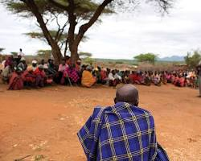
Group of people discussing the meaning of a folk song
3.2 Classical Music (Medieval and Renaissance)
This sub-strand focuses on the critical analysis and appreciation of classical music from the Medieval and Renaissance periods.
Key Concepts:
- Periods:
  - Medieval (approximately 500-1400 AD).
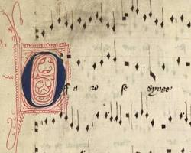
Medieval musical manuscript
  - Renaissance (approximately 1400-1600 AD).
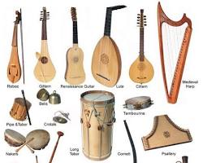
Renaissance musical instrument
- Genres in Medieval Period:
  - Plain song (Gregorian chant).
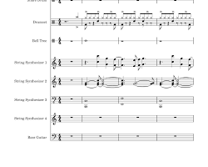
Plain song musical notation
  - Organum (early polyphony).
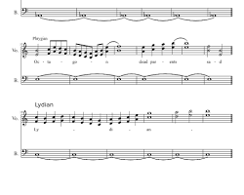
organum musical notation
  - Motet (polyphonic choral composition).
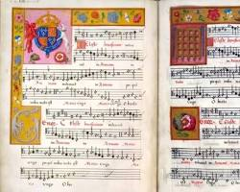
medieval motet manuscript
- Genres in Renaissance Period:
  - Motet (more developed polyphony).
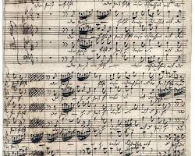
Renaissance motet manuscript
  - Madrigal (secular vocal music).
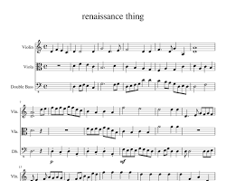
Renaissance madrigal score
  - Mass (polyphonic choral setting of the Mass).
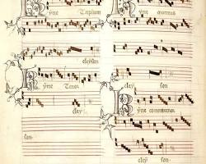
Renaissance mass manuscript
  - Toccata (keyboard virtuoso piece).
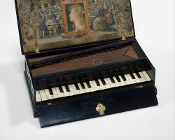
Renaissance keyboard instrument
  - Canzona (instrumental ensemble piece).

Suggested Learning Experiences:
- • Listen to and discuss the characteristics of music genres in the prescribed periods:
- • Discuss the influences of the characteristic of the period on the features of the music:
- • Responsibly search for, listen to and aurally identify the prescribed music genres of the different periods by outlining the composer and the features of music:
- • Develop informed personal responses to music of the prescribed periods:
Practical Application:
- Listening to and analyzing recordings of Medieval and Renaissance music.
- Identifying and describing the characteristics of different genres.
- Researching the historical context of the music.
- Discussing the influences of the periods on the music.
- Developing personal responses to the music.
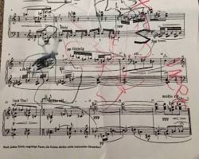
someone analyzing a classical music score
3.3 Music and Dance in Socio-cultural Context
This sub-strand focuses on understanding the role and impact of music and dance within various social and cultural settings.
Key Concepts:
- Functions:
  - Religious (spiritual expression).
  - Social (celebrations, gatherings).
  - Educational (teaching, storytelling).

performance used for educational purposes
  - Economic (entertainment industry).
  - Cultural (preserving traditions).
- Changing Musical Practices:
  - Timing (length of performances).
  - Language (use of different languages).
  - Costume and make-up (evolving styles).
  - Age of performers (generational shifts).
  - Audience (changing demographics).
  - Packaging of messages (modern communication).
  - Collaborations (cross-genre and cross-cultural).
  - Instrumentation (use of new instruments).
  - Handling of props and dance movements (new techniques).
Suggested Learning Experiences:
- • Listen to or watch performances of music in various contexts and discuss its functions:
- • Discuss the changing musical practices in different performance settings:
Practical Application:
- Analyzing music and dance performances from different social and cultural contexts.
- Discussing the functions of music and dance in various settings.
- Examining how musical practices have changed over time.
- Researching the impact of music and dance on society.

Teachers are advised to consult curriculum designs whenever teaching

