Structure and bonding
1. Ethanol contains molecules 1 which are not1 responsible for electrical conductivity
2. a) A covalent bond is formed by equal contribution of the shared electrons by the atom. 1
Co-ordinate bond is where the shared electrons are contributed by one of the atoms.1

H
H
H
H
x
•
x •
•
x
x
•
x •
H

HN H

H
•
x
•
x
• x
• x
H

HNH

H

OR

3. a) Have delocalized valency electrons 1
b) Aluminium is a better conductor/Aluminium has three delocalized electrons while
magnesium has 2. 1 It is resistant to corrosion.
4. In addition to vander waals forces, strong hydrogen bonds exist in ethanol. These bonds
require  more energy to break.

5. a) Is a covalent bond in which the shared pair of electrons comes from the same atom
6. Magnesium has more delocalized electrons than sodium
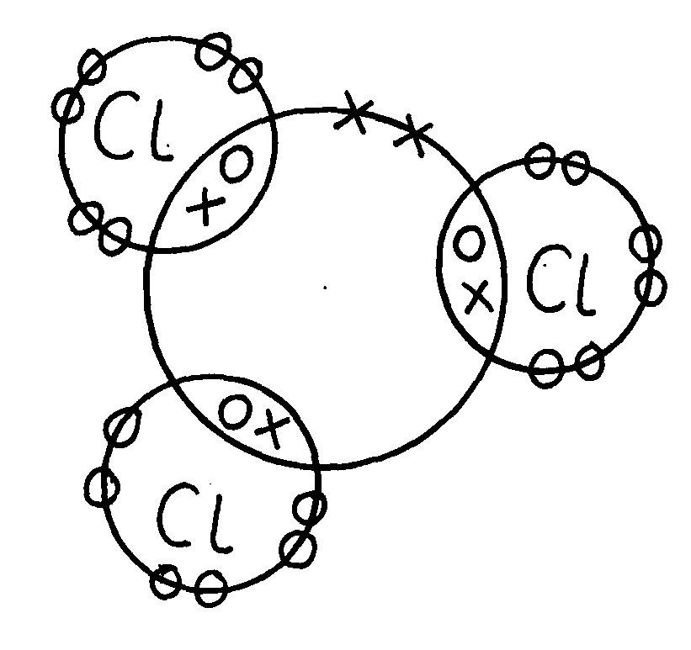
7. (a) Phsophorous chloride (PCl₃)

P

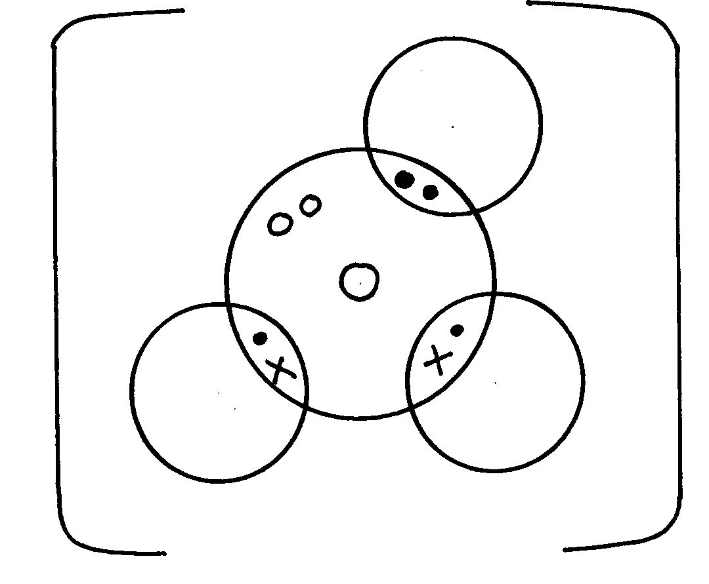
(b) Hydroxonium ion (H₃O⁺)
H

O

H
H

8. Aluminium – it has more delocalized (3) electrons than copper (2 e_)
9. Hydrogen chloride has got only Van der waal while water has H-bonds in
addition to Van der waal forces which are stronger
10. It contains white hoe carbon particles (½mk) that allow to give out light (½mk). When those
particles cool down (½mk) they turn black and settle down as soot.(½mk)
11. Aluminium chloride hdrolyses ^{√1} in solution producing hydroxonium ions ^{√½} which turn blue
litmus paper red. ^{√½}
12. Silicon (IV) oxide forms giant ^{√1} atomic structure of strong covalent^{√½} bonds having high
melting point. Carbon (IV) oxide is simple molecular substance of weak intermolecular ^{√½}
attraction forces^{√1} 9the Van der Walls’ forces) that have low melting point.
13. i)A: 2,4√ ½
B: 2,7√ ½
14. (a) Because aluminium √1 has more delocalized √1 electrons than magnesium.
(a) It does not corrode. √1
15. Magnesium oxide has a giant ionic √ ½ structure while silicon (iv) Oxide has a giant atomic
structure. Mg O in molten state √ ½ contains delocalized ions √ ½ which conduct electricity
while S₁O₂ has no ions present √
16. a) i)
ii) At 25C, sodium chloride is in solid form. Ions cannot move. Between 801 and
1413C sodium chloride is in liquid state, ions are mobile

b) Both ammonia and water are polar molecules and hydrogen bonds are formed

c) N _________ H // co-ordinate bond / Dative bond

d) i) Allotrope
ii) Add methylbenzene to soot in a beaker. Shake and filter. Warm the filtrate to
concentrate it. Allow the concentrate to cool for crystals to form. Filter to obtain
crystals of fullerene
iii) ⁷²⁰/₁₂ = 60
17. (a) (i) NACl has mobile ions in molten state and in aqueous solution
(ii) Graphite has delocalized electrons in the structure which carry electric current
18. (i) I) C Reason:- Good conductor of electricity in both molten and solid state..

II) D-Its melting point is below room temp. and boiling point above room temp.

(ii) It exist in allotropic form.
(iii) A conducts electricity by use of mobile ions while C conducts by use of delocalized
electrons.
Both must be correct for the 1 mk.
19. I (a) 2Na(_{s)} +2CH₃CH₂OH_{(l)} 2CH₃CHONa_{(aq)} + H_{2(g)}
(b) Mole ratio btn Na: H = 2:1
Mole of Holes H₂ = 1200cm³
2400cm³
= 0.05moles
Moles of Na = 0.05 x 2
= 0.1moles
Mass of Na = 0.1 x 23
= 2.3g of sodium

(c) Mole ration C₂H₅OH:H₂
Moles of C₂H₅OH = 0.05 x 2
= 0.1moles
mass of C₂H₅OH reacted = 0.1 x 46
= 4.6g
Mass evaporated = 50 - 4.6
= 45.4g of C₂H₅OH

(d) – Has molecular structure – with hydrogen bonds being molecules
While - C₂H₅ONa – has giant ionic structure with ionic bonds
(a) Water
(b) In ethanol – sinks in water and stream of bubbles observed /seen
While in water – floats on water and darts on water
- Hissing sound is heard (any two)
20. (a) ionic or electrovalent
F is metal and H is non metal.
b) (i) J atomic radius decrease a long a period from left to right nuclear change attraction
increase positive nuclear change increase due to increase in the number of protons.
(ii) F has a smaller atomic radius than N level down the grown.
c) W is group 5 period 3
d) Transition metals.
e) J has 3 valence electrons which and delocalizal whole Q has only 2 electron : hence J
has high electrical conductivity due to high number of decalized electron.
f) The reactions have both metallic and non metal properties
g) H is more reactive than M non metal reactivity increase up the group due to decrease
in electro negativity down the group.
21. (a) (i) Ionic bond
Y losses that is gained by Z
(ii) Atomic radius of A is larger than that of B has higher nuclear charge than A Electrons in B are drawn closer to the nucleus( ½mk)
(iii) Z is more reactive than B
Z has a smaller atomic radius so will readily attract extra electron
(b) (i) Energy needed to remove an electron from an atom in gaseous state
(ii) R has a largest atomic radius; (½mk)
Therefore the electron is easily lost
(iii) Reacts vigorously with water producing gas bubbles that give the hissing sound and
propels the metal
The metal floats on water as it is light
(iv) 2Q_{(s)} + H₂O_{(l)} 2QOH_{(aq)} + H_{2(g)}

22. a) i)
Atomic number | Oxide formula | State at RT
N-12 | P₂O₃ | Q - solid
R- 15 | R₂O₅ | S- Gas

ii) The atomic radius decreases across the period from M to V. Due to increasing
nuclear charge// increasing number of protons which pulls the outermost electrons
closer to the nucleus

iii) Element V is chemically stable// stable electronic configuration does not gain or
loss// share electrons with oxygen to form an oxide

b) i)
Oxide | Structure | Bond type
No | Giant ionic | Ionic/ electro valent
TO2 | Simple covalent/ molecular | Covalent
( ½ mark each – total 2 marks)
c) i) P is a metal with valency electrons free to move but T is a non- metal// molecular has
no free valency electrons// molecules are electrically neutral

ii) Amphoteric oxide

23. (i) Period 2 its electronic arrangement is 2,3, or it has two energy levels.
- Accept shells or orbitals in place of energy levels
(ii) I- Across a period nuclear charge increases from, left to right exerting greater
pull/attraction on available electrons
II-A₄ gains an electron and the incoming electron is repelled by other electrons or
electron cloud increases
(iii) A₂
A₄
A₁
•
x
+
_
x
•
x xx
x

(iv)
 1

24. a) P₂Q √ reject QP₂

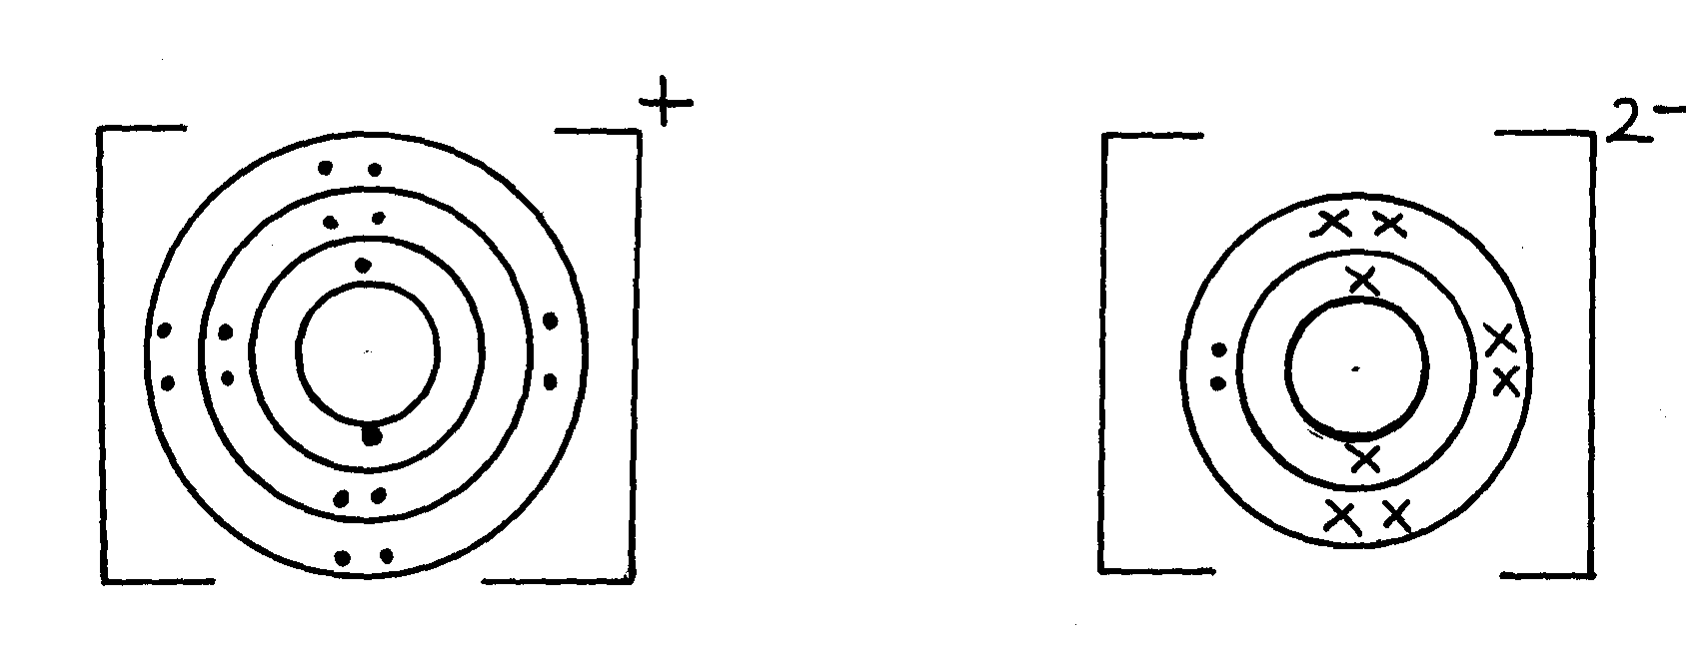
2

25. (i) Ice : Bonding : - Covalent ^{√ ½} ½ mk
Structure : - Simple molecular ^{√ ½} ½ mk 2
(ii) Magnesium chloride : Bonding : - Ionic ^{√ ½} ½ mk
Structure: - Giant ionic ½ mk
26. (i) Ice : Bonding : - Covalent ^{√ ½} ½ mk
Structure : - Simple molecular ^{√ ½} ½ mk 2
(ii) Magnesium chloride : Bonding : - Ionic ^{√ ½} ½ mk
Structure: - Giant ionic ½ mk

27. (a) Zinc oxide √1 ZnO (1 mk)
(b) ZnO_{(s)} + H₂SO_{4(aq)} √1 ZnSO_{4(aq)} + H₂O (1 mk)
3
2-
(c)
Zn (OH) √1 (1 mk)
4

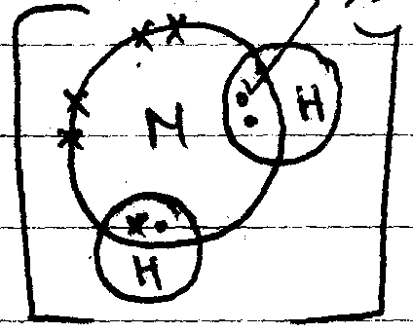
28. (a)

Electrons  ½
Charge  ½

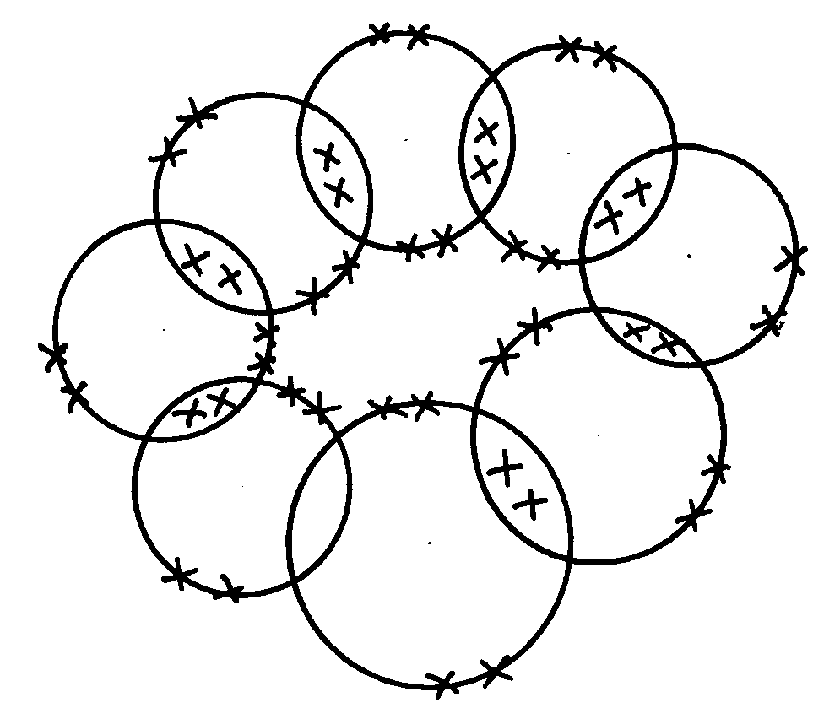

 1

 1
(b) C O
29. Diamond has giant atomic structure in each carbon atom√ ½ is bonded to four other √ ½
carbon atoms arranged in regular tetrahedron shape in all direction forming rigid (strong)√ ½
mass of atoms due to uniformity of covalent bonds between the atoms√ ½ (2mk)
30. 3 Covalent ^{√1} bonds and one dative ^{√1} bond
31. - CB₂
- Ionic bond
32. (a) Covalent bond is bond between non-metal atoms where shared electrons are donated
equally by all the atoms involved.
Dative bond is a bond in which shared electrons are donated by one atom.
 ½
(b) The presence of triple bond in nitrogen requires very high temperatures to break
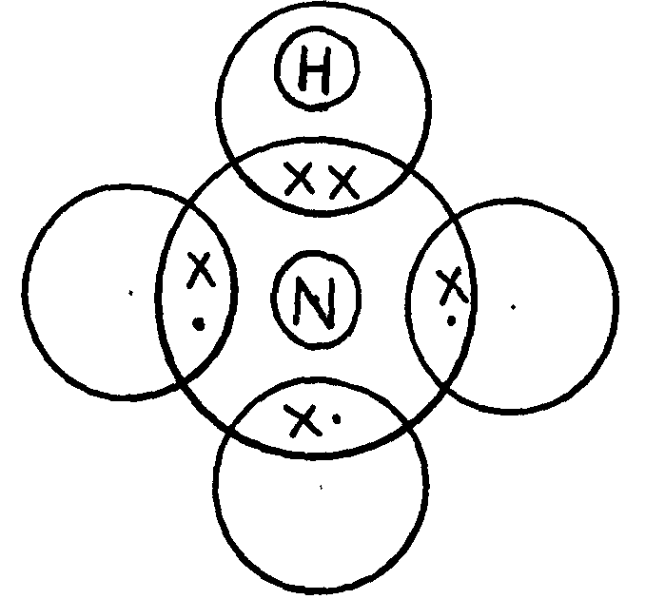
33. (i)
 1
- award 1mk if one Hydrogen two electrons donated by nitrogen
- 0mk if all hydrogen atoms shares electron with nitrogen

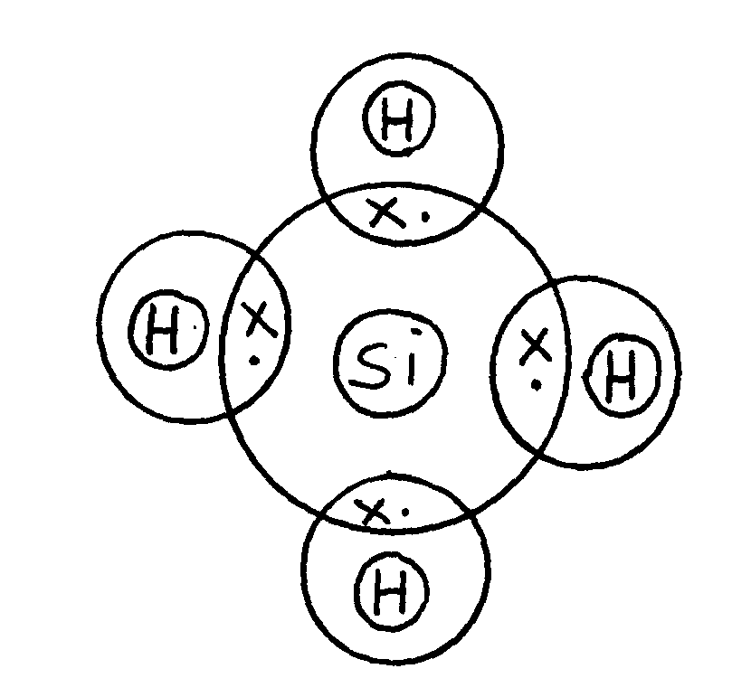
 1
- award full mark if Silicon and Hydrogen shares electrons

34. (a) Chlorine (I) Oxide
 ½
 ½
 ½
(b) - Na₂O has stronger ionic bond between ions in it, while SO₂ has a weak Van der walls bond
between its molecule
- ∴Na₂O requires more heat energy to weaken or break the ionic bonds than SO₂ requires
 ½
breaking Van der walls bonds
35. ALCL₃ has simple molecular structures with weak Vander waals between the molecules
M_{g}CL₂ has giant ionic structures with strong ionic bonds
Due to insoluble coating of aluminum oxide which prevents any reaction √1

